Deploying a Scalable 3-Tier Web Application Architecture on AWS

**Project Report**

**Title:** "Deployment and Teardown of a Secure 3-Tier Web Application Architecture on AWS”

**Course:** AWS(Amazon Web Services)

**Student Name:** Laxman

**Project Objective:-**

This project aims to design, deploy, and decommission a fully functional 3-tier architecture web application on AWS. The architecture separates the presentation, application, and data layers for security, scalability, and maintainability.

**The project utilizes core AWS services including:-**

**•** EC2 for web (frontend) and application (backend) servers

**•** RDS (DB) for the relational database tier

**•** S3 for storage of static content and backups

**•** VPC, NAT Gateway, Elastic IP, and Route 53 for secure networking and DNS management

**•** Security Groups and Certificates for secure access and HTTPS communication

**•** AMIs and Snapshots for backup and recovery

The project also demonstrates a clean deletion lifecycle, where all resources are removed in a systematic order, ensuring no dangling or chargeable components remain after decommissioning

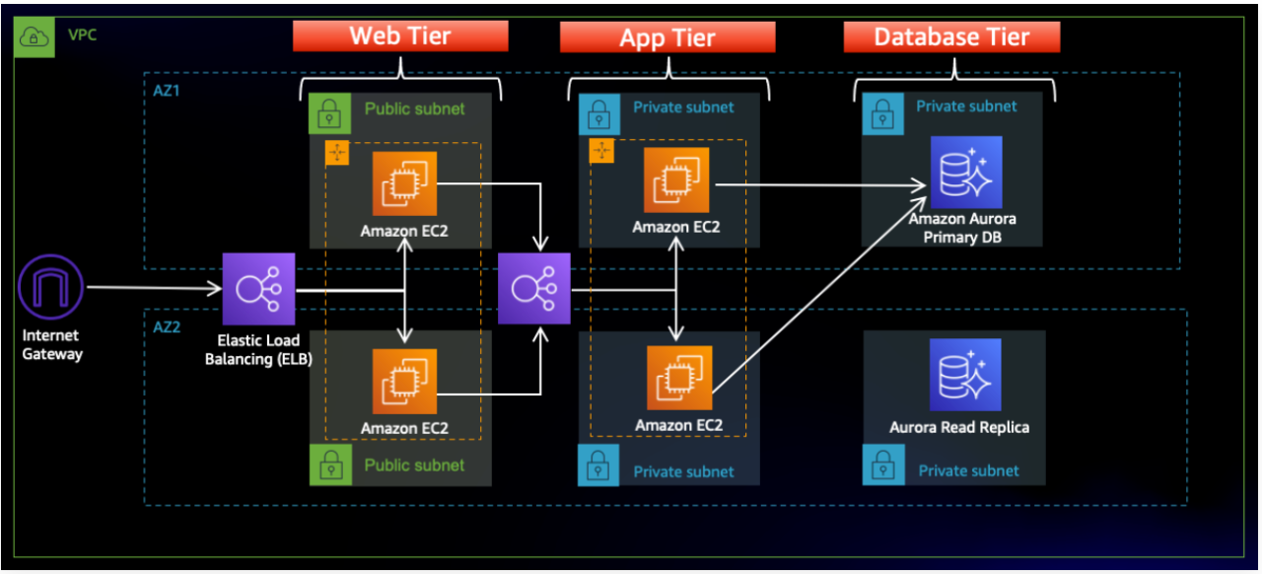

**Configuration Details**

Creating the AWS Console account

**Requirements:- To Creating AWS Account**

1. Gmail ID
2. Phone no

iii) Residential Address

iv) Debit Card for international Payment

v) Pan Card

**Now start the Poject Executing**

**Open the AWS Console**

1. Open any browser & Search AWS
2. Open the First Link

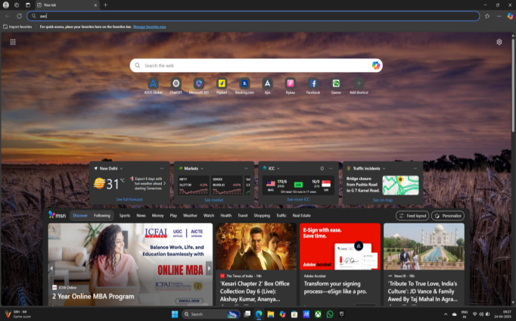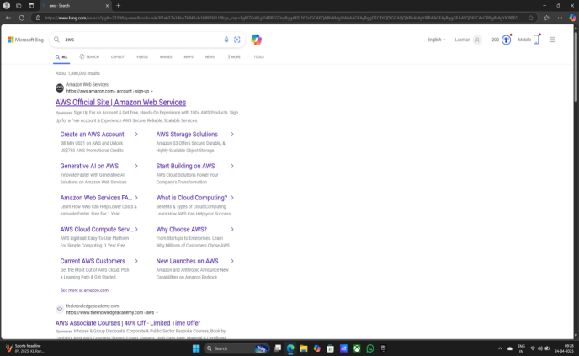

iii) Sign in to the console

iv) After creating AWS account you see EC2 Home page

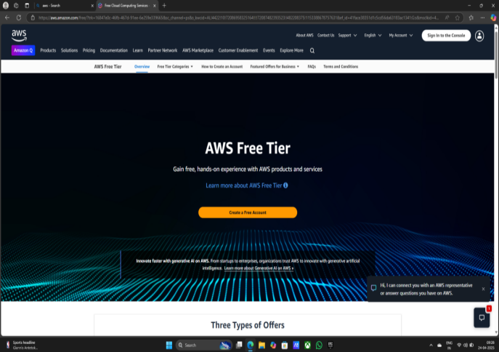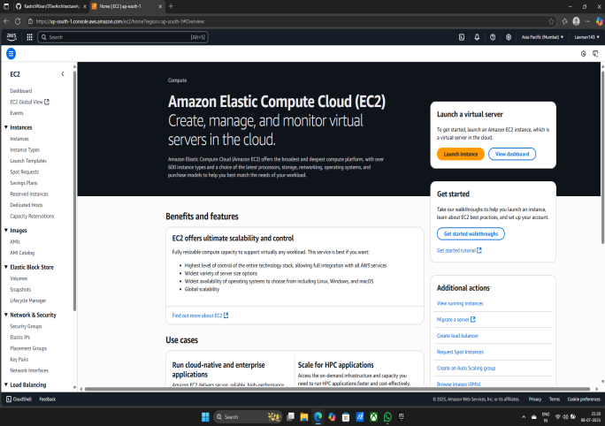

**Now Creating VPC Step by Step & Your subnet is also create in Creating VPC**

**Creating VPC and Subnets**

1. Click on Search bar type VPC
2. Click on VPC & Create VPC

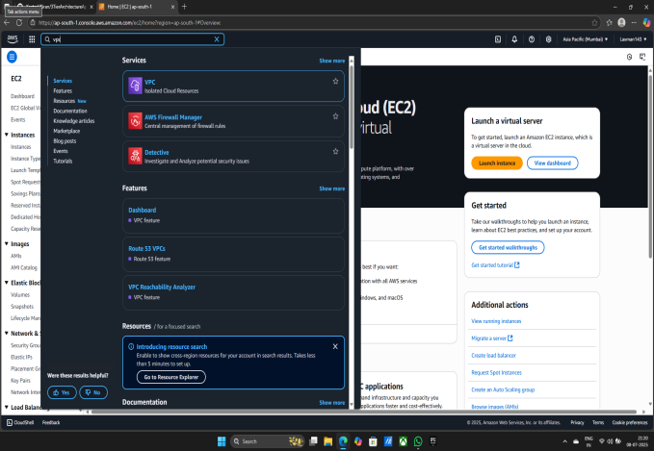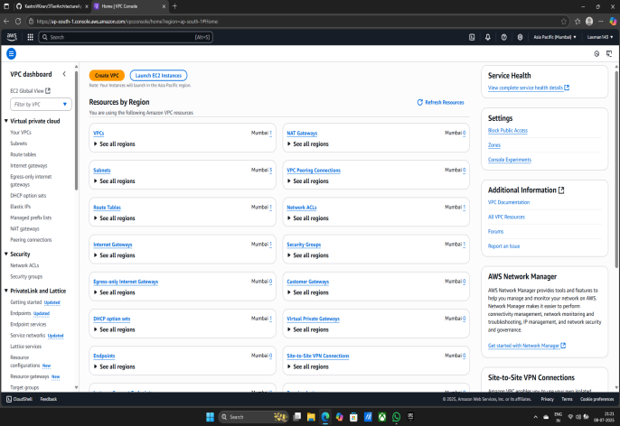

1. Give Name tag

iv) IPv4 CIDR Block - (192.168.0.0/22)

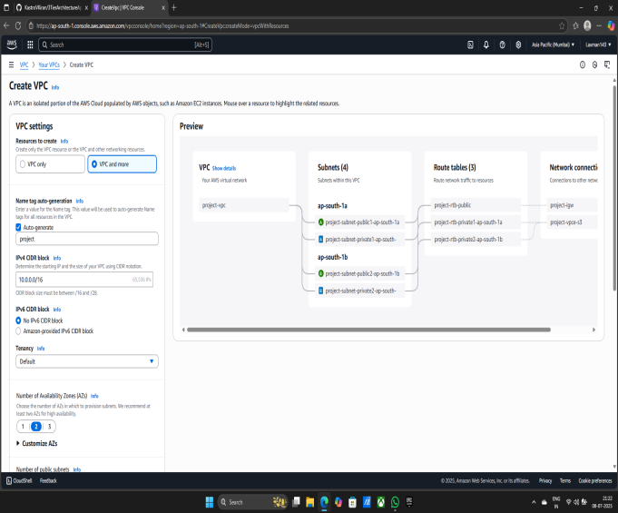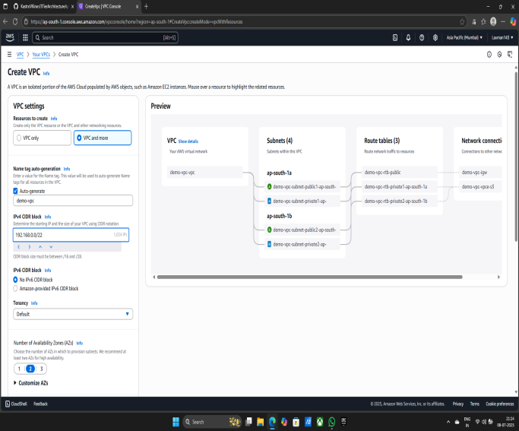

v) Number of private Subnets - (4)

vi) NAT gateways ($) - (IN 1 AZ)

vii) VPC endpoints - (None)

viii) Create VPC

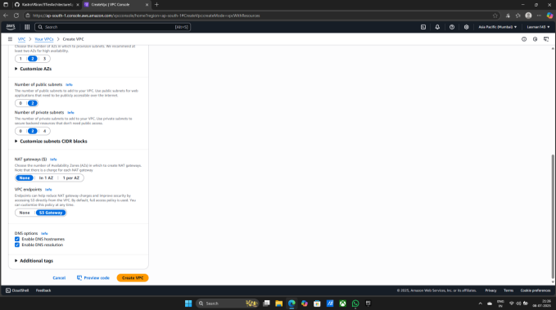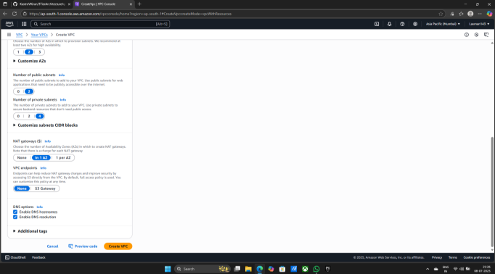

ix) Now your VPC creating they will take 3 to 5 minutes

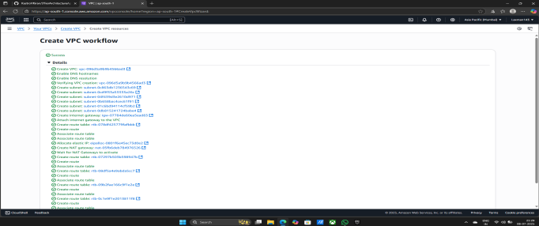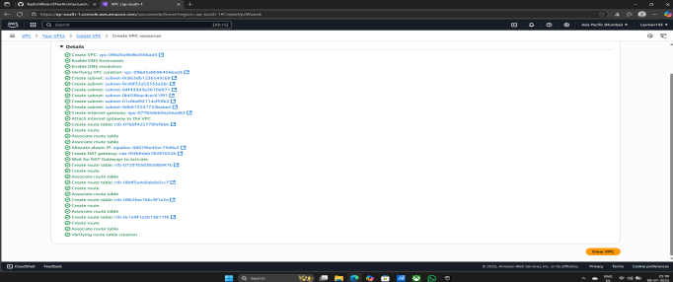

x) Now you see your VPC is Created

xi) Your subnets also created

xii) You see your subnet in subnets session

**Created six subnets:-** a) 2 public subnet for instaces

b) 2 private subnets for App

c) 2 private subnets for Data Base

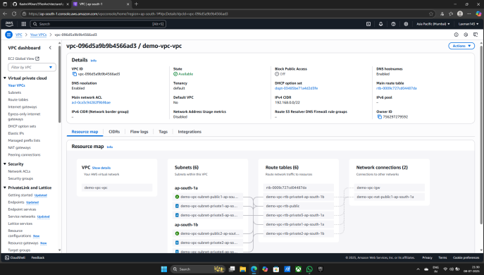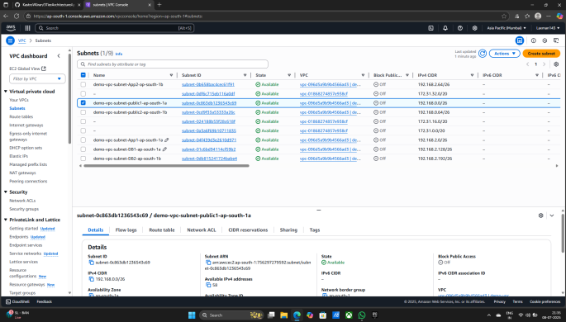

**Now Creating Five Security groups lets creating First group**

**Creating Security group in VPC**

i) Now In your VPC you go to Security

ii) Click on Create Security group

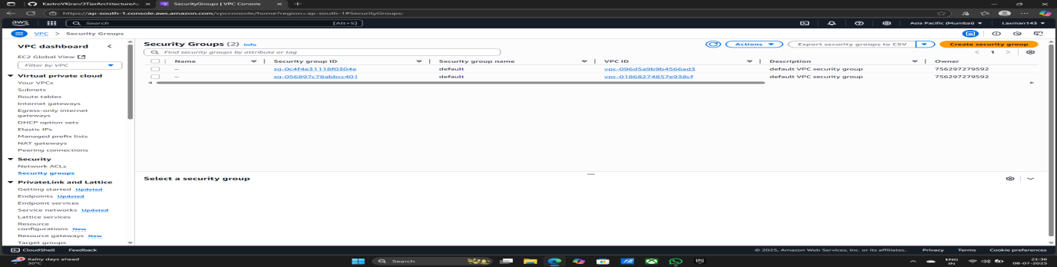

iii) Give any name to Security group - Web-ALB-SG

iv) Give any Description - Web-ALB-SG

v) Select Created VPC - demo-vpc

vi) Add Inbound rules - a) Type- Http

b) Source - Anywhere , 0.0.0.0/0

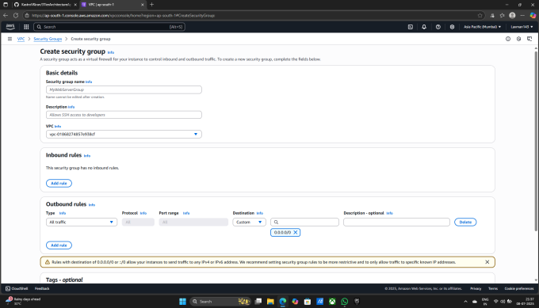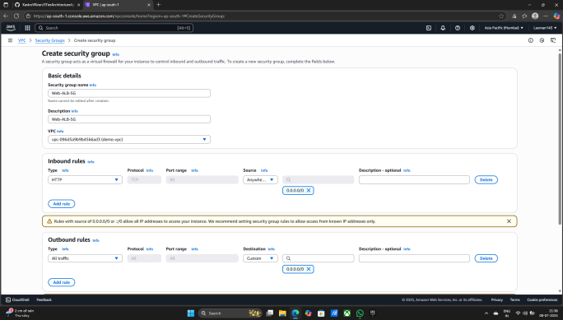

vi) Now Click on Create Security Group

vii) Security group is successfully Created

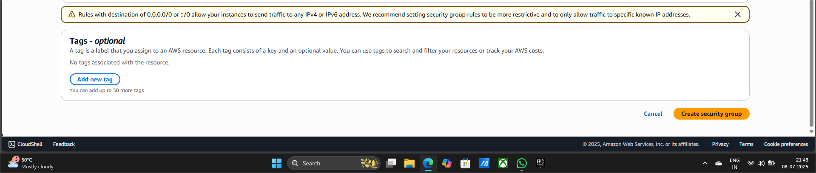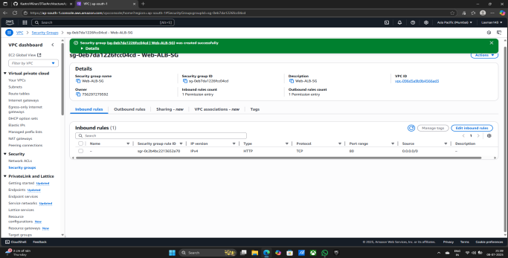

**Now Creating second Security group**

1. Give any name to Security group - WEB-SG
2. Give any Description - WEB-SG
3. Select Created VPC - demo-vpc
4. Add Inbound rules - a) Type - HTTP

b) Source - Custom - select - WEB-ALB-SG

c) Type - HTTP

d) Source - Custom - select - Created Network - (192.168.0.0/22)

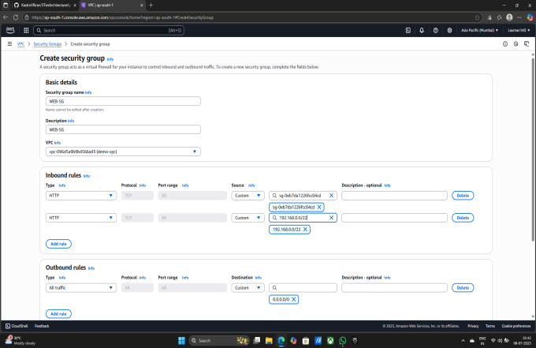

vi) Now Click on Create Security Group

Vii) Security group is successfully Created

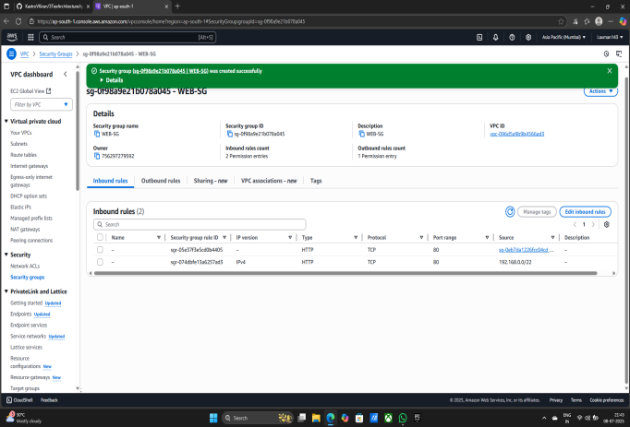

**Now Creating Third Security group**

1. Give any name to Security group - APP-SG
2. Give any Description - APP-SG
3. Select Created VPC - demo-vpc
4. Add Inbound rule - a) Type - Custom TCP

d) Port range- 4000

c) Source- Custom - select - Created Network - (192.168.0.0/22)

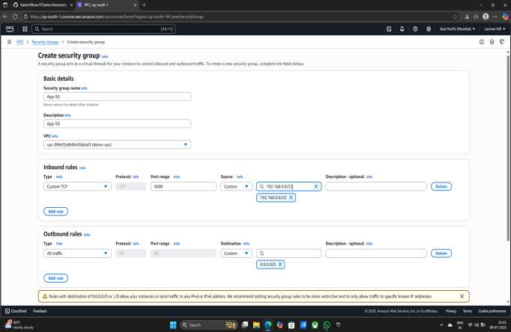

1. Now Click on Create Security Group
2. Security group is successfully Created

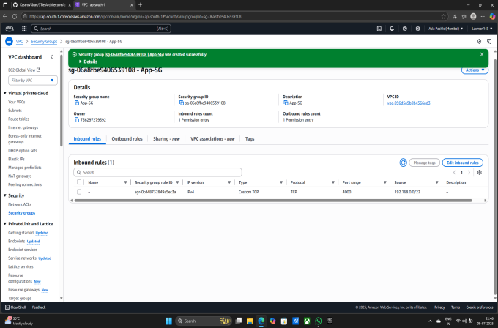

**Now Creating Forth Security group**

1. Give any name to Security group - Internal-ALB-SG
2. Give any Description - Internal-ALB-SG
3. Select Created VPC - demo-vpc
4. Add Inbound rule - a) Type - Custom TCP

b) Source- Custom - select - Created Network - (192.168.0.0/22)

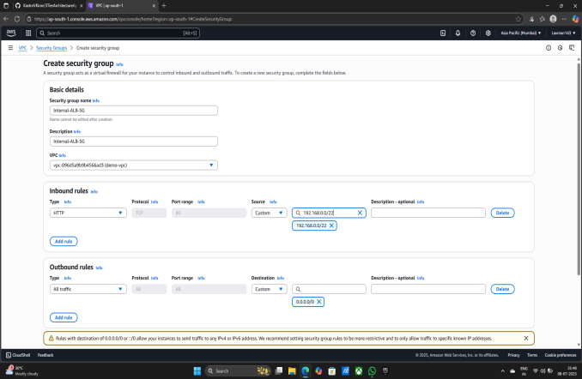

1. Now Click on Create Security Group
2. Security group is successfully Created

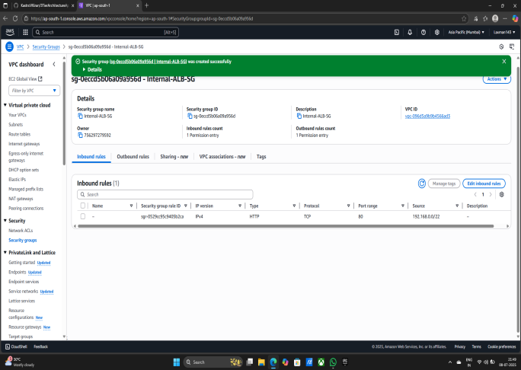

**Now Creating Fifth Security group**

1. Give any name to Security group - RDS-SG
2. Give any Description - RDS-SG
3. Select Created VPC - demo-vpc
4. Add Inbound rule - a) Type - MYSQL/Aurora

b) Source- Custom - select - Created Network - (192.168.0.0/22)

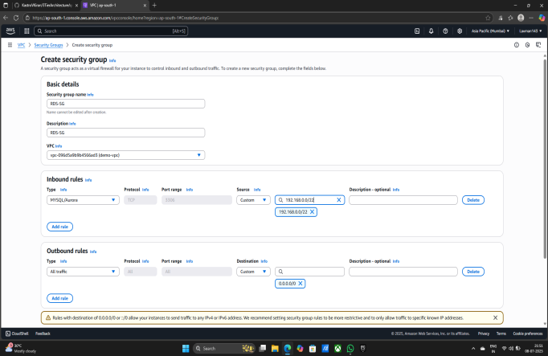

V) Now Click on Create Security Group

Vi) Security group is successfully Created

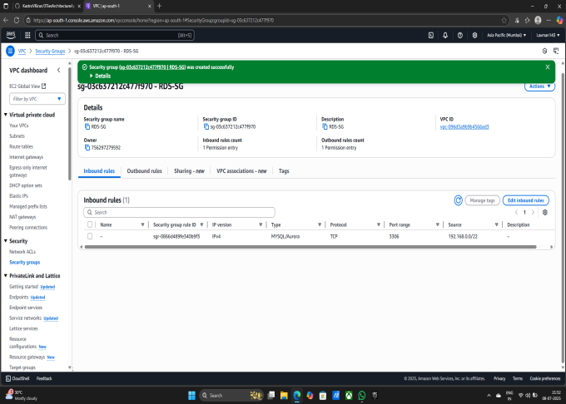

**Five Security Groups are successfully Created**

**•** WEB-ALB-S

**•** WEB-SG

**•** RDS-SG

**•** App-SG

**•** Internal-ALB-SG

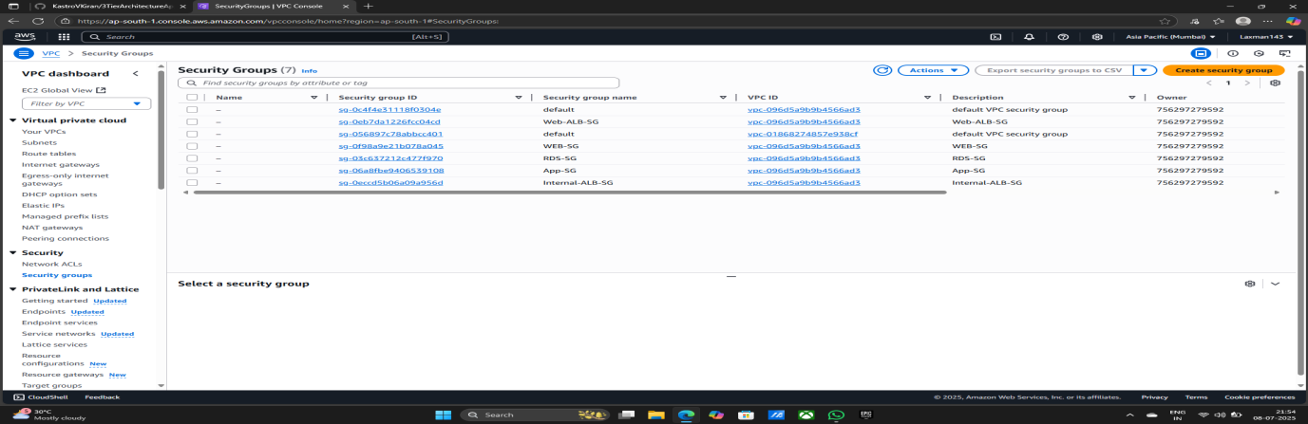

**Now copy the code from gitHub and copying in My physical PC**

1. Now copy the link and paste on the browser
2. [KastroVKiran/3TierArchitectureApp: This repository consists of the files related to the 3TierArchitectureApp](https://github.com/KastroVKiran/3TierArchitectureApp)
3. Now you see gitHub account
4. Click on code
5. Copy url to dipboard

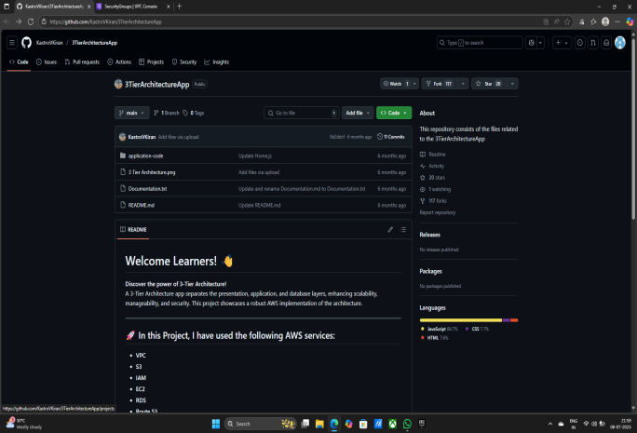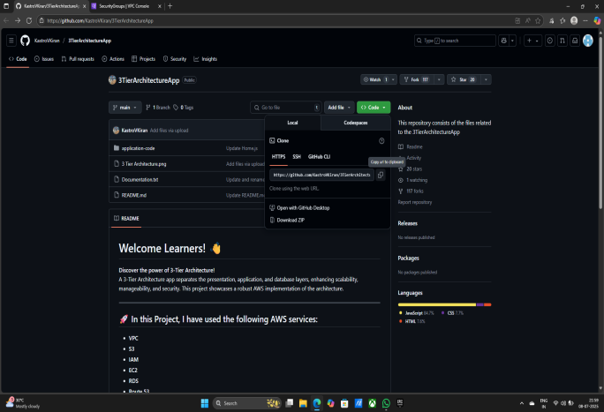

1. Go to This PC file
2. Right click & Open Git Bash here
3. Terminal is Open
4. Type:- a) git clone (Paste your copyed code here)

b) git clone https://github.com/kastroVKiran/3tierArchitectureApp.git

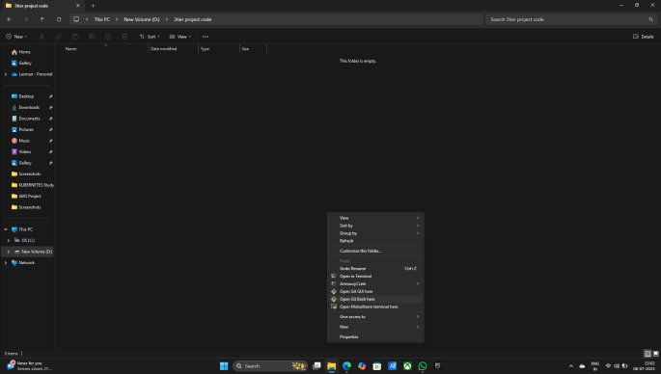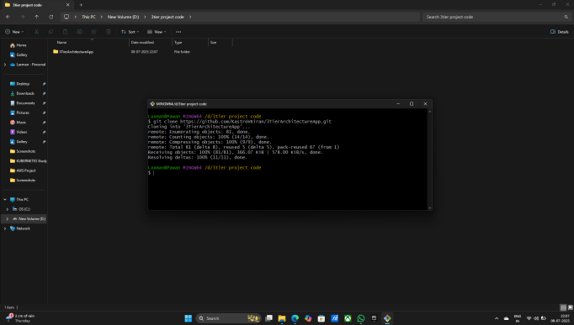

1. Code is Now copyed in This PC file
2. Enter in the application-code file

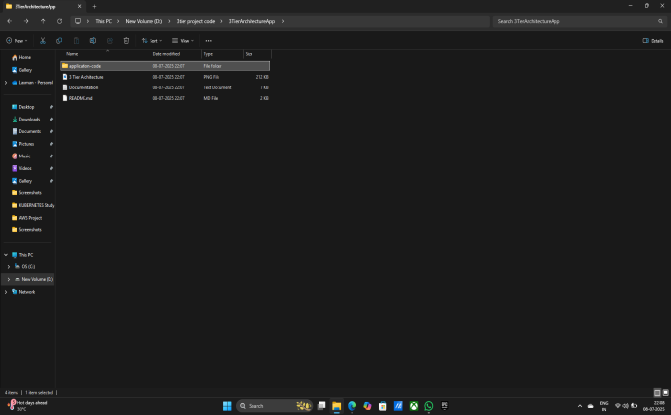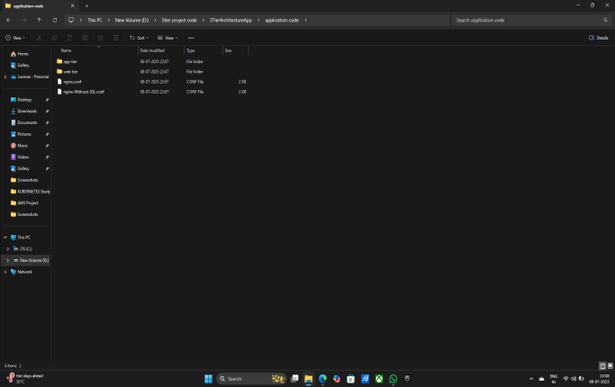

**Now Creating S3 Bucket**

1. Search S3
2. Click on S3 Bucket
3. Click on Creating Bucket

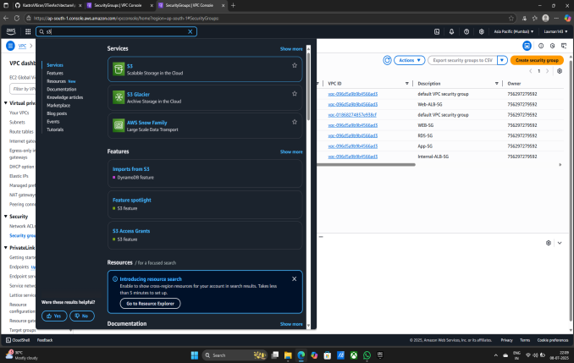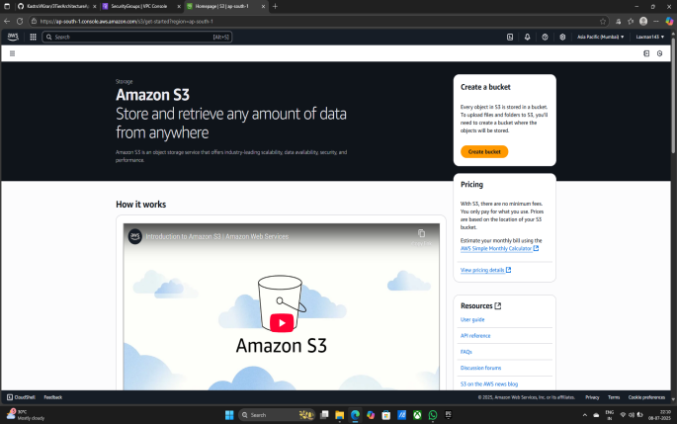

1. Give any name to Bucket - demo-3tier-project123

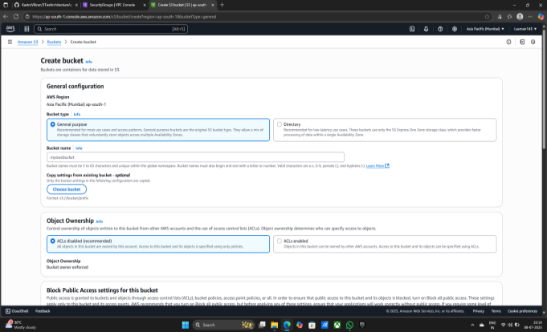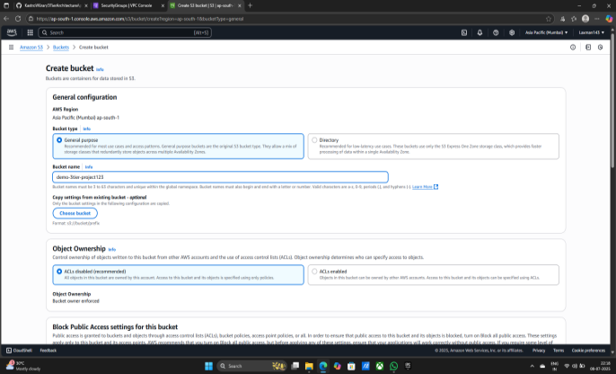

1. Now Click on Creating Bucket

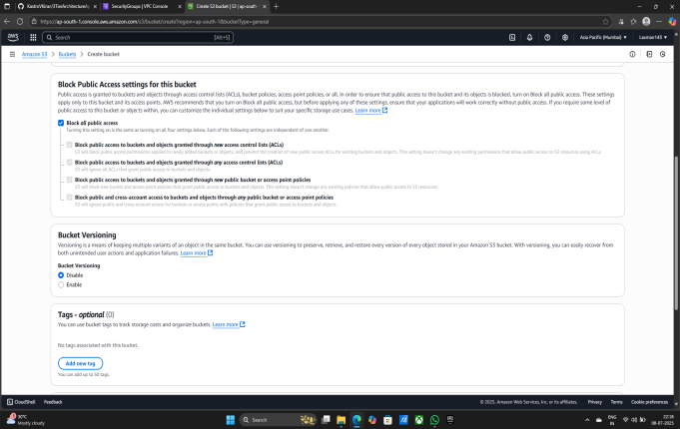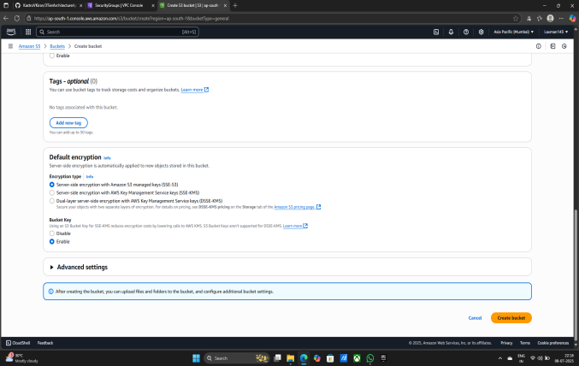

1. Now Bucket is Ready
2. Select Bucket & Go inside the Bucket
3. Click on upload file

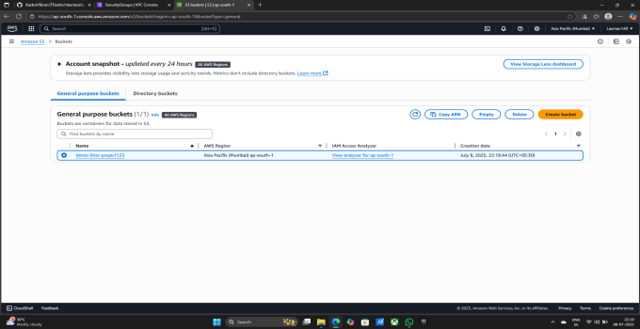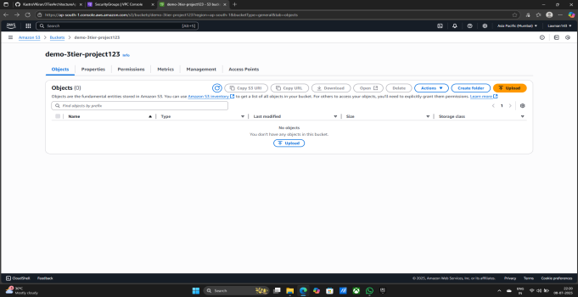

1. Select file from your location
2. Select only application-code file
3. Drag it and upload in S3 Bucket

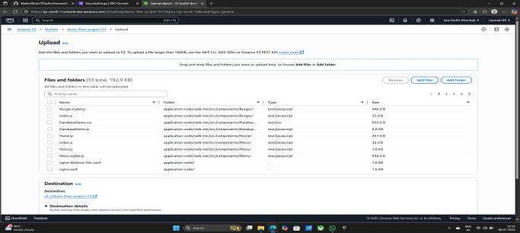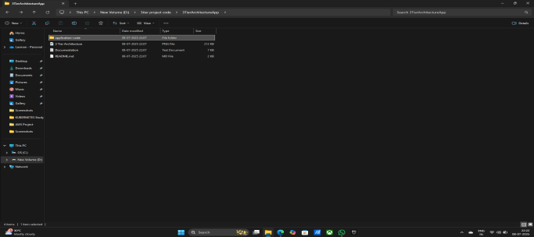

1. Click on upload
2. Now your file is successfully uploaded
3. Now Click on close button

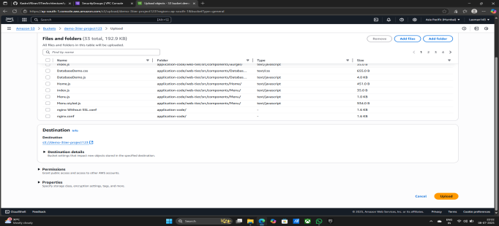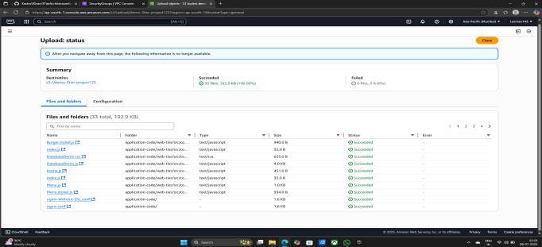

**Now Creating IAM Role**

1. Search IAM
2. Click on IAM

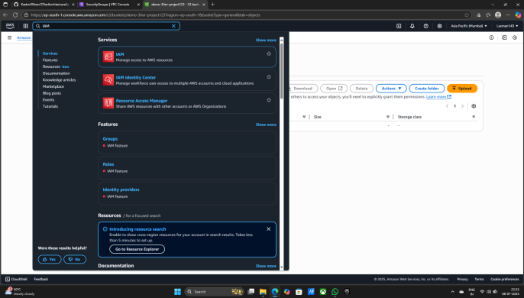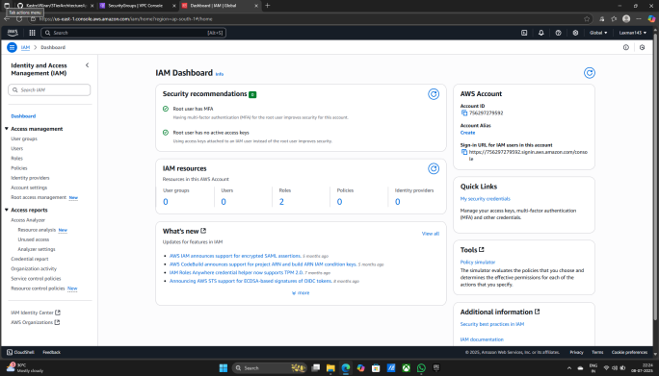

1. In Access management go in Roles
2. Now Click on Create role
3. Trusted entity type - AWS service
4. USE case - EC2

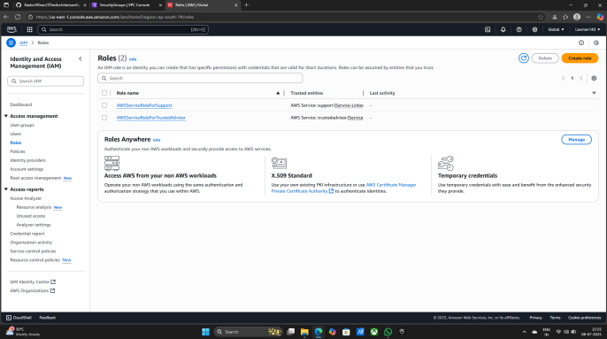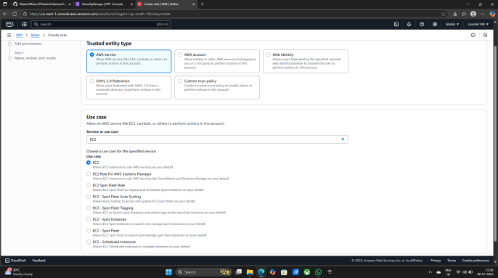

1. Click on Next
2. Again click on Next

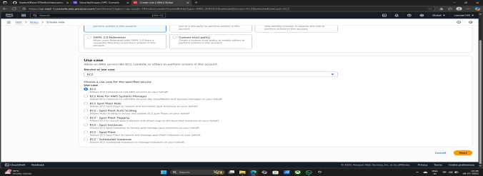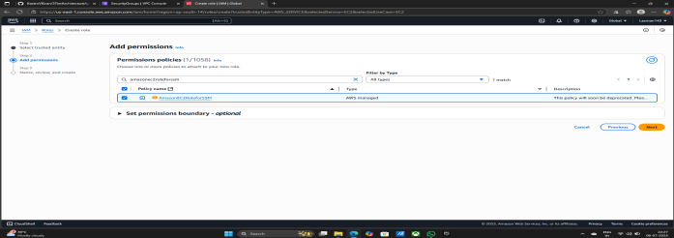

1. Role name - Demo-EC2-Role
2. Description - Allows EC2 instances to call AWS services on your brhalf.
3. Now Click on Create role

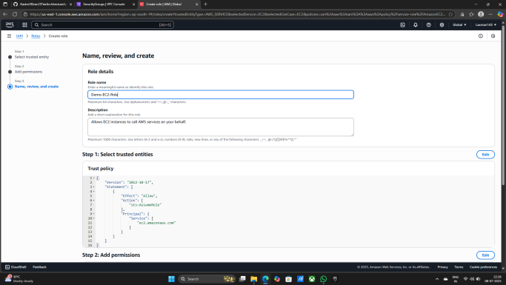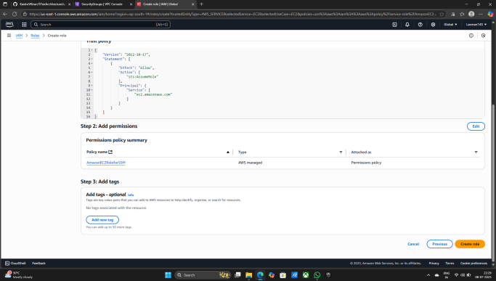

1. Now Your AMI Role is Created Successfully

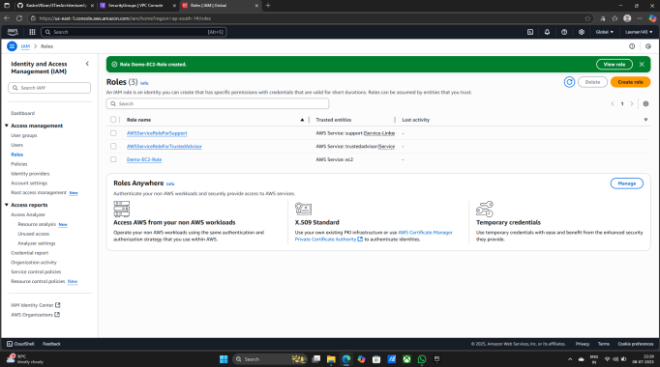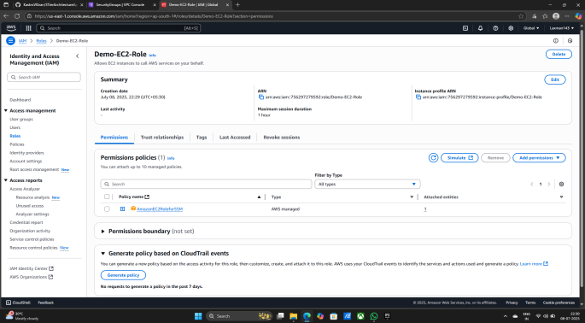

**Now Creating Aurora and RDS**

1. Search RDS
2. Click on Aurora and RDS

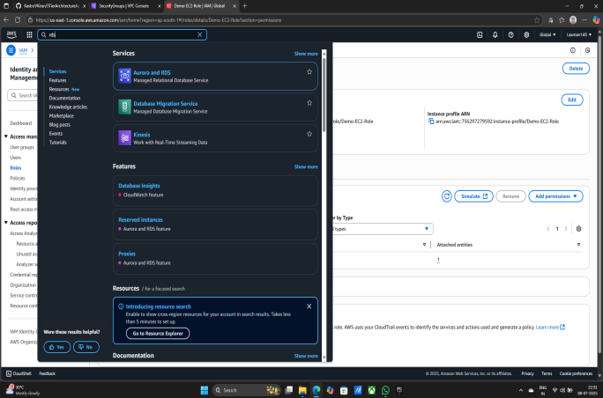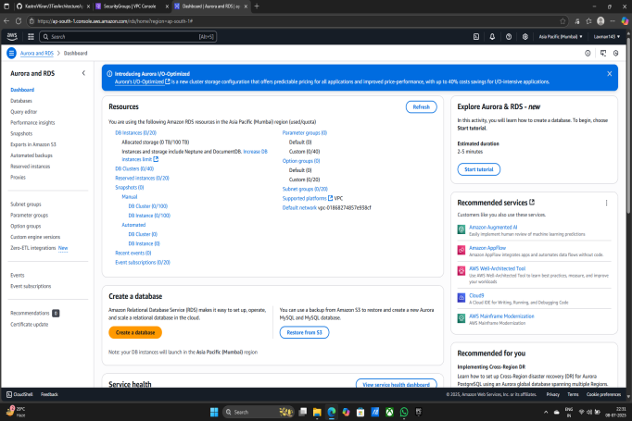

1. Now Click on subnet groups
2. Now Click on Create DB subnet group

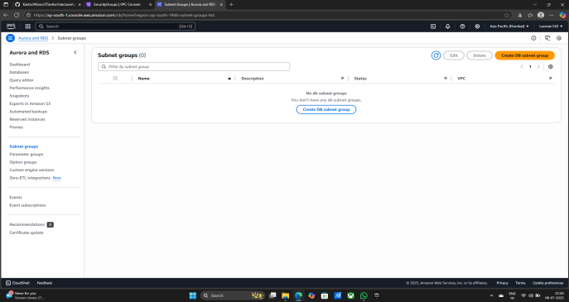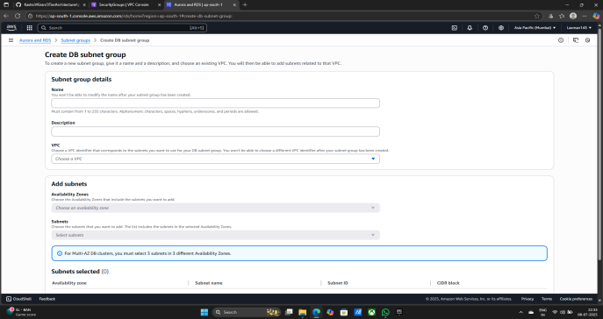

1. Name - DB-SNGP
2. Select Created VPC - demo-vpc
3. Availability zones - a) demo-vpc-subnet-DB2-ap-south-1b

b) demo-vpc-subnet-DB1-ap-south-1a

1. Click on Create

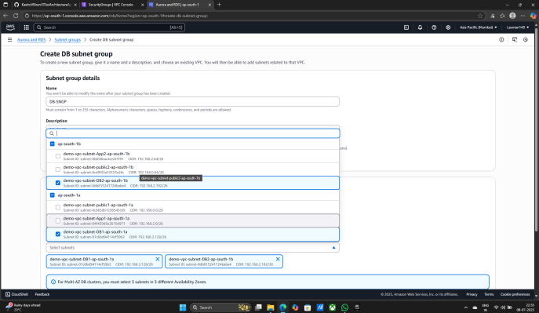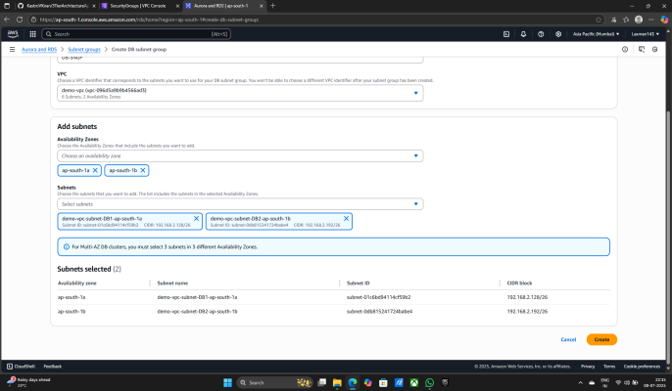

1. Subnet group is successfully Created
2. Now click on Database
3. Again click on Create Database

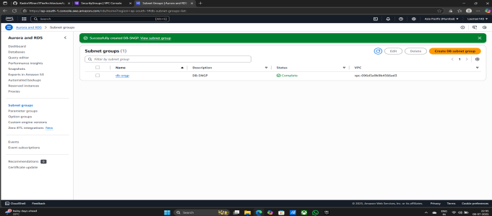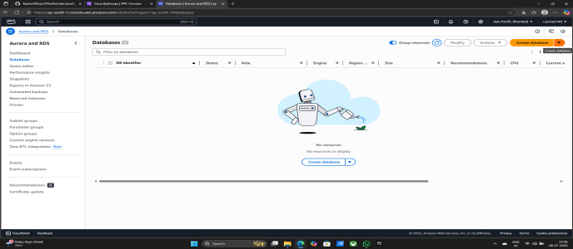

1. Engine options - MYSQL

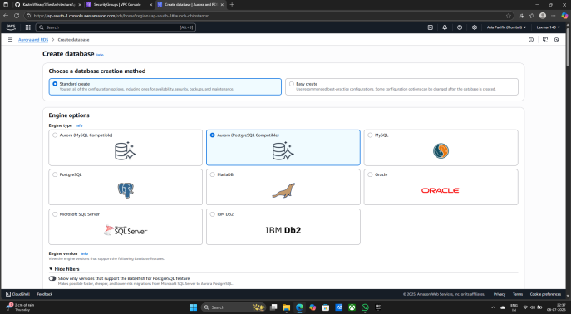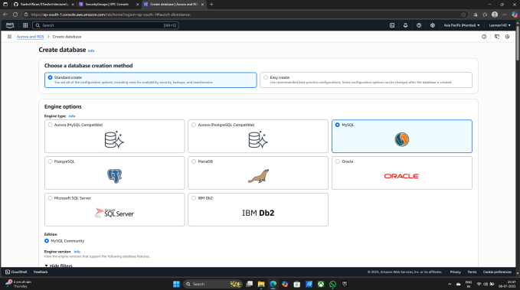

1. Templates - Free tier
2. Availability and durability - Single-AZ DB instance deployment (1 instance)

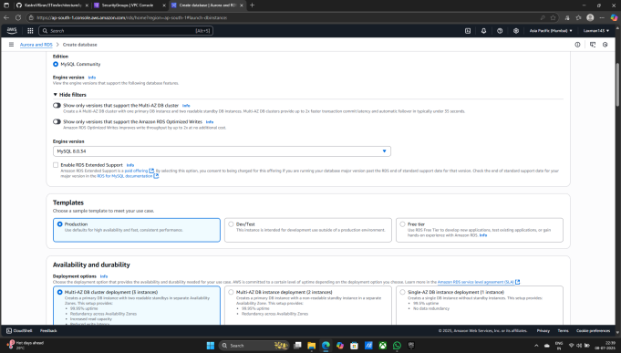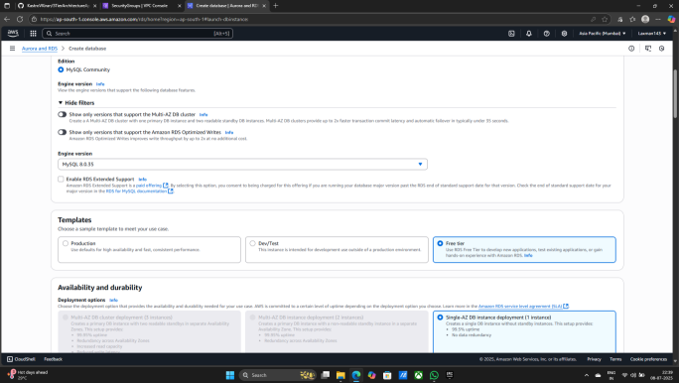

1. DB instance identifier - database-1
2. Master username - admin
3. Give Master password - Laxman@123
4. Give Confirm master password - Laxman@123
5. DB instance class - db.t4g.micro

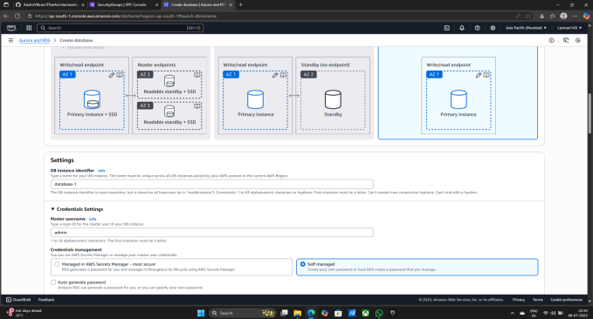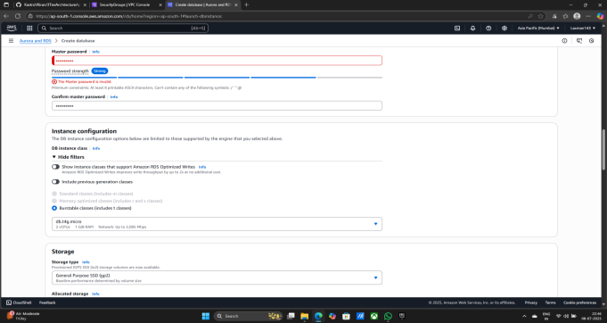

1. Virtual private cloud (VPC) - demo-vpc
2. DB subnet group - db-sngp

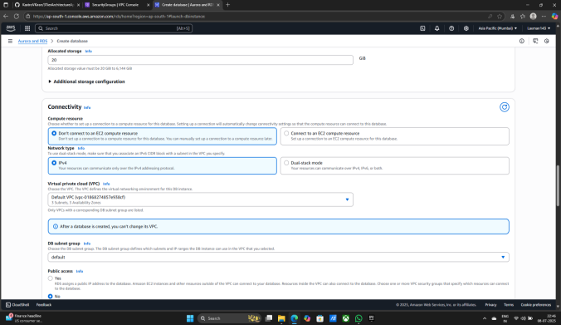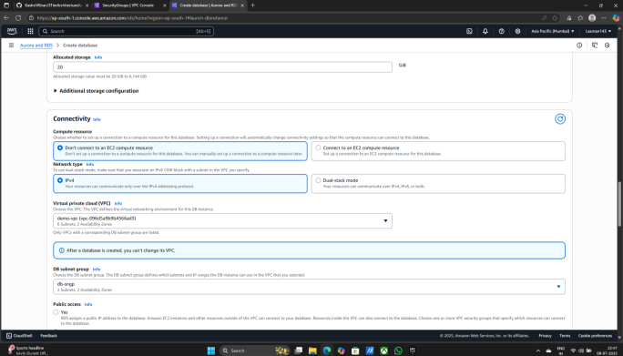

1. Choose VPC security group (firewall) - Choose existing
2. Existing VPC security group - RDS-SG

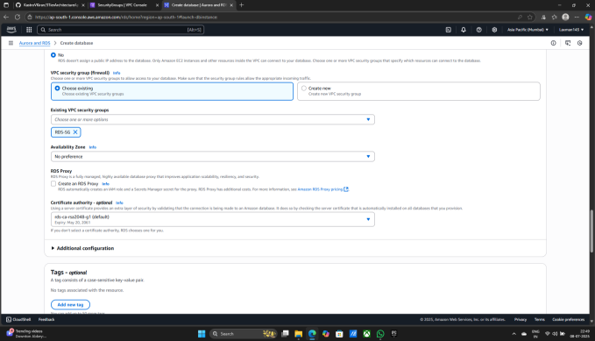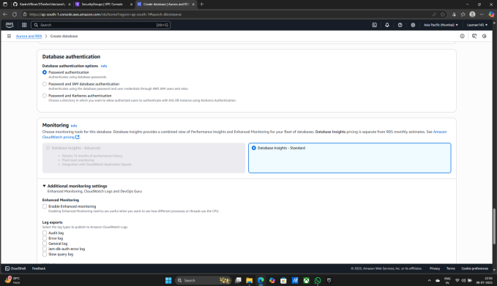

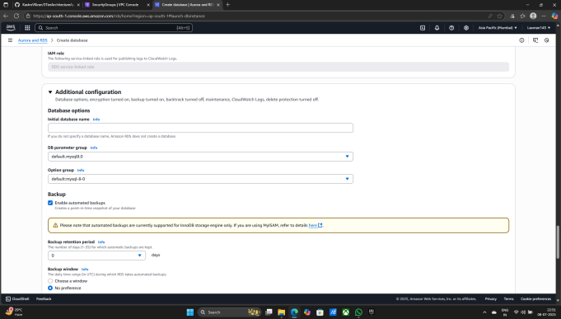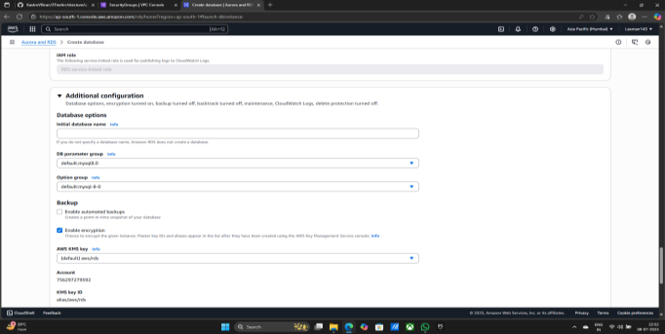

1. Now Click on Create database
2. Now database will be creating they also take some time

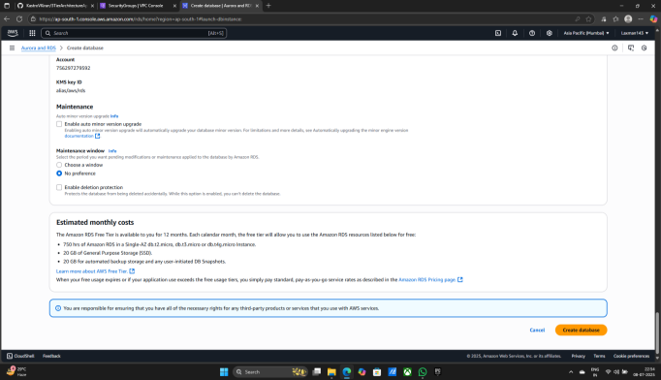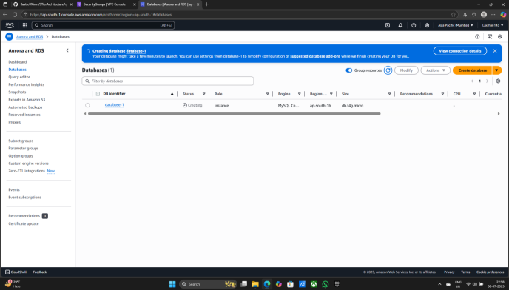

1. Now database-1 Status is Creating

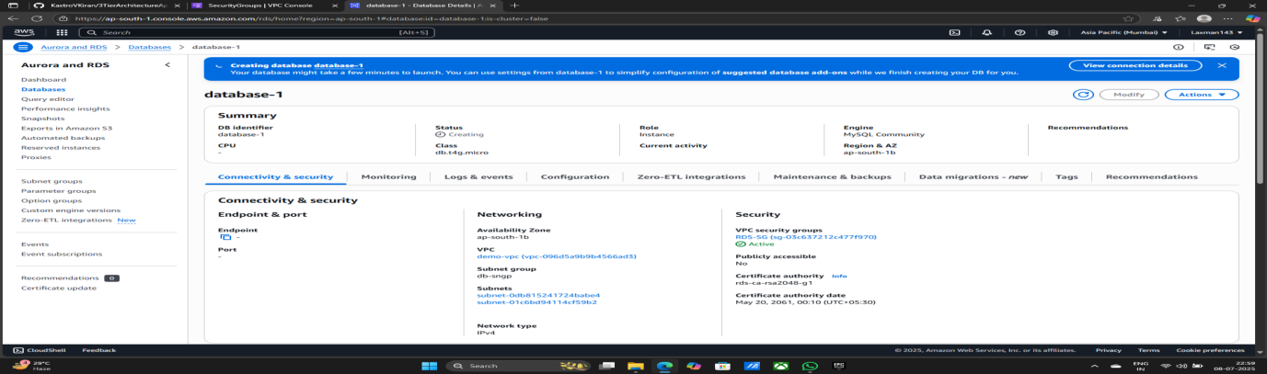

**Now Creating EC2 Instances for app tier.**

1. Search EC2
2. Click on EC2
3. Click on Instances

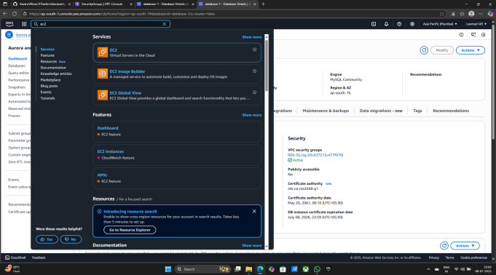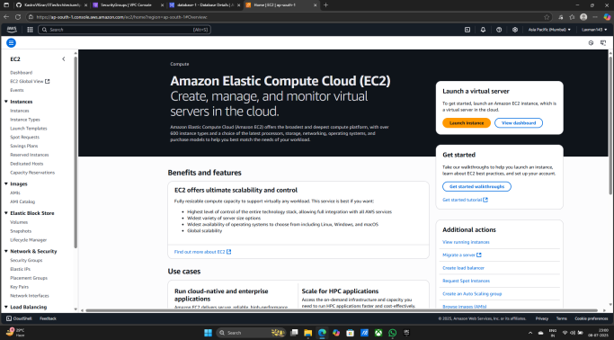

1. Click on Launch Instances

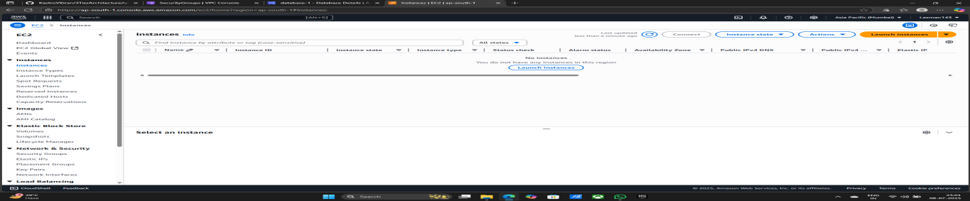

1. Give Name on Instance - AppTierInstance

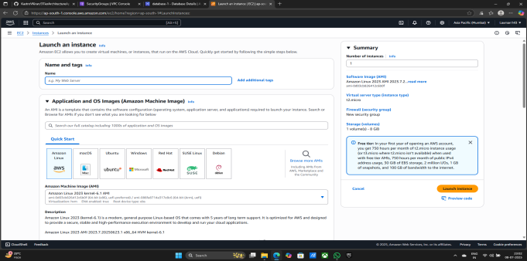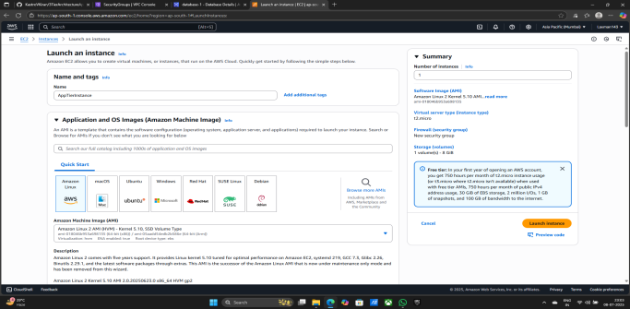

1. Creating Key pair (login) - 1) Give Key pair name - MyNew1
2. Key pair type - RSA
3. Private key file format - .pem
4. Click on Create Key pair

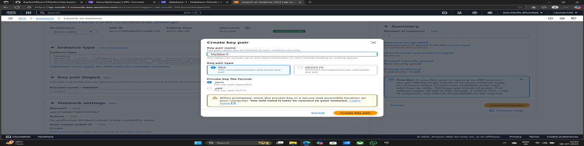

1. Select Created key pair name - MyNew1

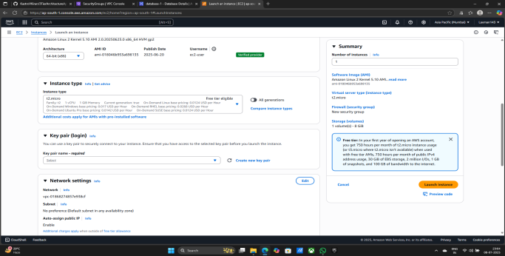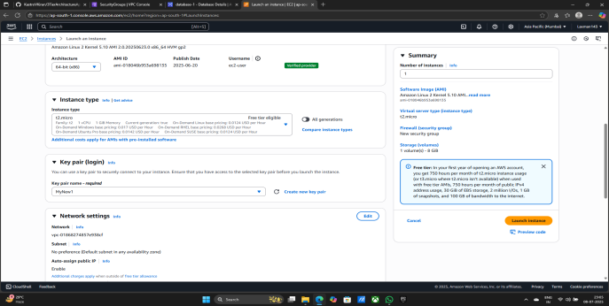

1. Select Created VPC - (demo-vpc)
2. Select Created App subnet - demo-vpc-subnet-App1-ap-south-1a
3. Auto-assign public IP - Disable
4. Select Firewall (security groups) - 1) select existing security group
5. Select App-SG Securit Group

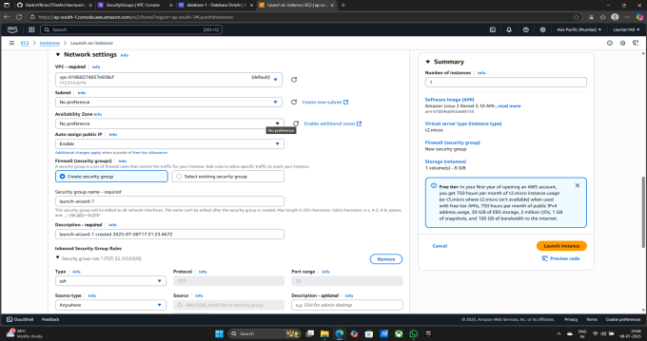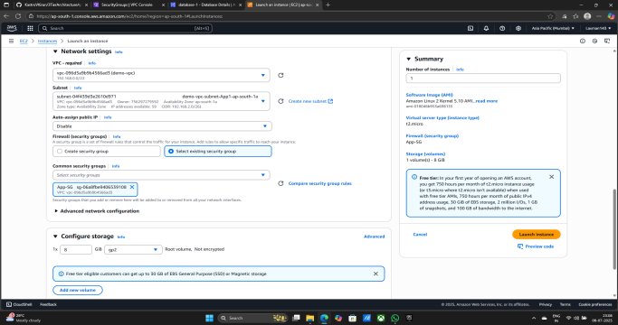

1. Click on Advanced details
2. Click on IAM Instance profile
3. Select Created Role - Demo-EC2-Role

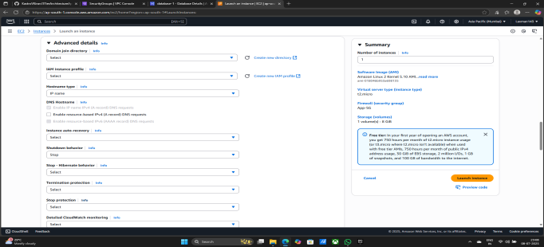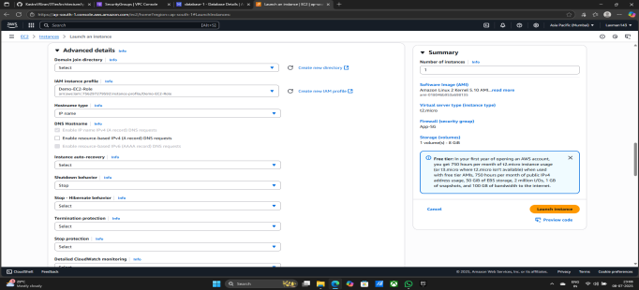

1. Click on Launch instance
2. Instance is successfully Created

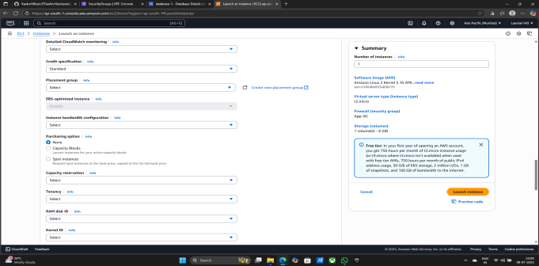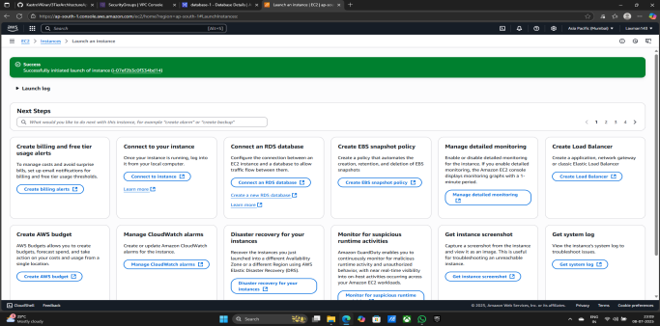

Now Start the Configration in AppTierInstance

1. Select Created Instance - AppTierInstance
2. Click on Connect
3. Again Click on Connect

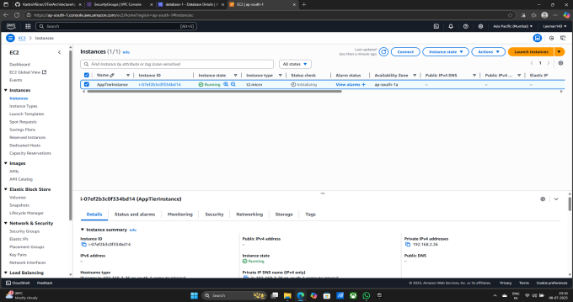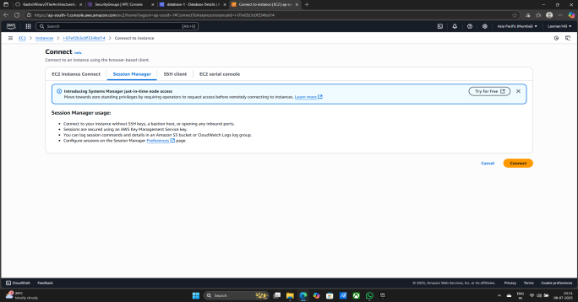

1. Commands Configration Step by Step:- 1) sudo su

2) whoami

3) cd ..

4) pwd

5) cd /home/ec2-user/

6) pwd

7) ping 8.8.8.8

8) Press - Ctrl+z

9) sudo yum install mysql-y

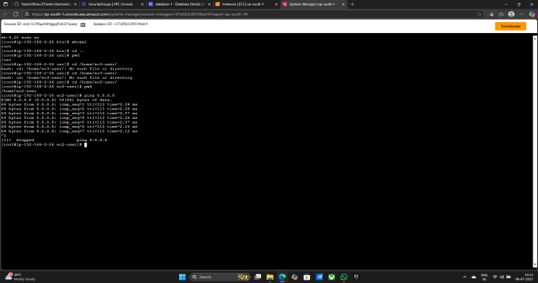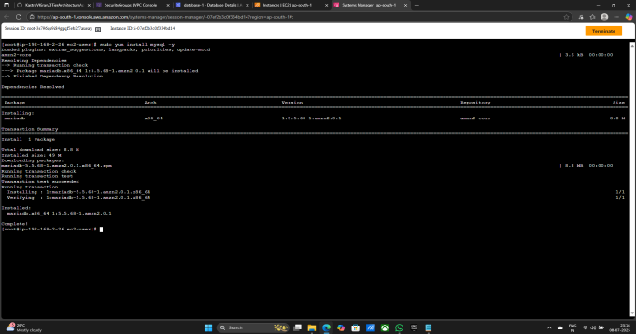

1. Now Go to database-1
2. Copy Endpoint in database-1
3. Command - mysql -h <copy database end point here> -u admin -p:- (mysql -h database-1.c98k8cmoo9vt.ap-south-1.rds.amazonaws.com -u admin -p)
4. Enter the password when you create database for access mysql - Laxman@123

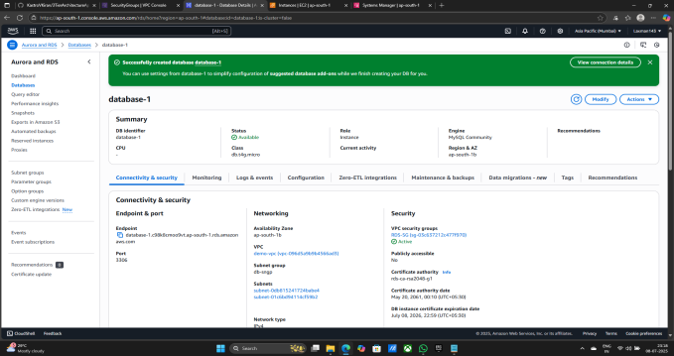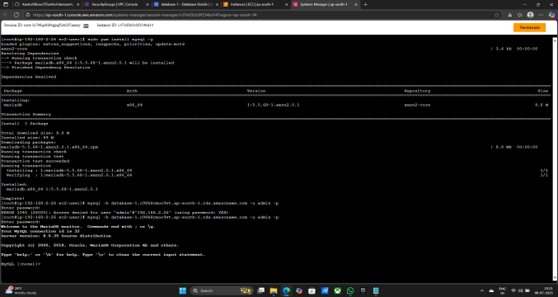

1. CREATE DATABASE webappdb;
2. SHOW DATABASES;
3. USE webappdb;
4. Creat database copy lower side content

CREATE TABLE IF NOT EXISTS transactions(

id INT NOT NULL AUTO_INCREMENT,

amount DECIMAL(10,2),

description VARCHAR(100),

PRIMARY KEY(id)

);

1. SHOW TABLES;
2. INSERT INTO transactions (amount, description) VALUES ('400', 'groceries');
3. SELECT * FROM transactions;
4. Press Ctrl+z exit from the mysql

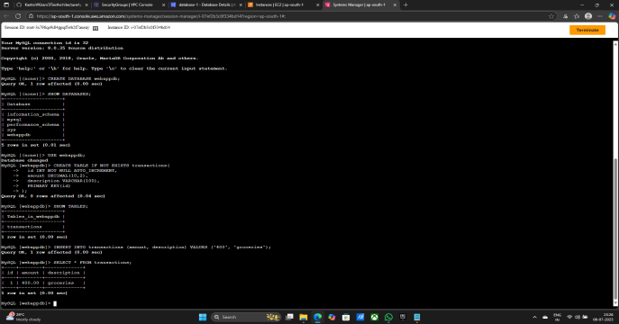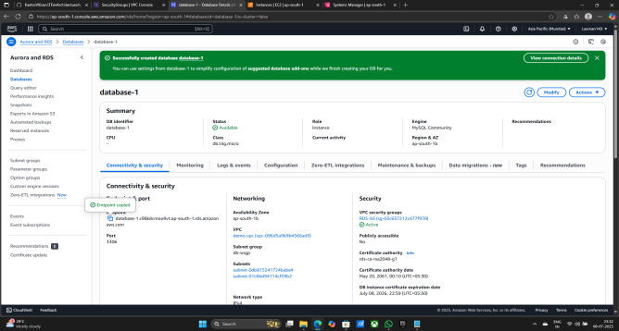

1. Now some changes in dbconfig file in application-code - 1) Change DB_HOST :- Paste database Endpoint Here

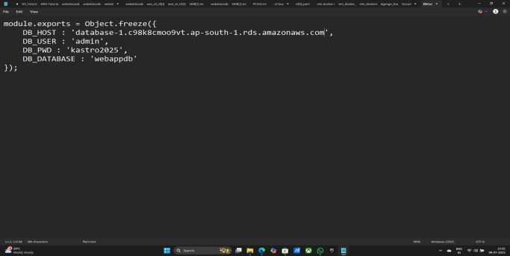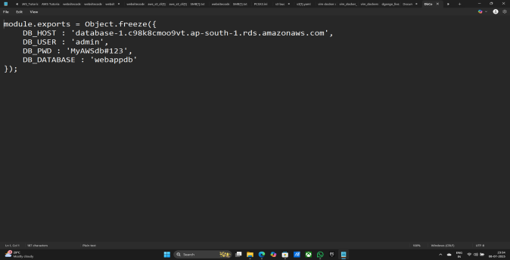

1. Now After changing code go to s3 bucket and upload the changed file dbconfig
2. Search s3 bucket & Click on s3 bucket
3. Click on demo-3tier-project123

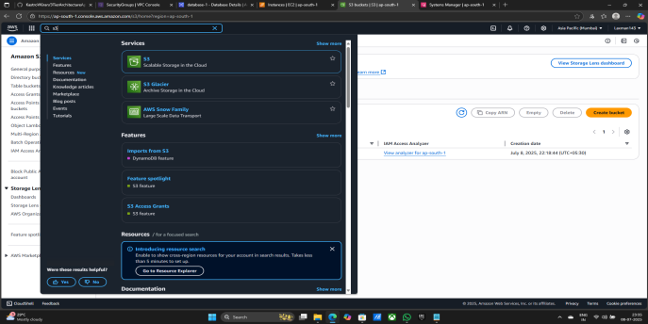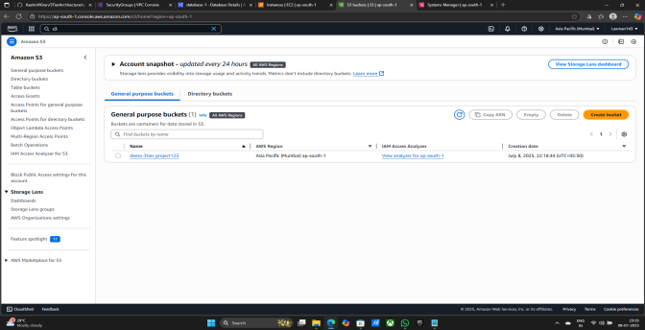

1. Now Click on upload changedfile here
2. Select the file in the folder

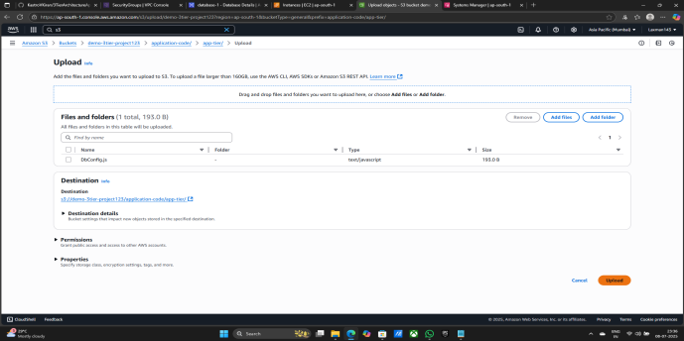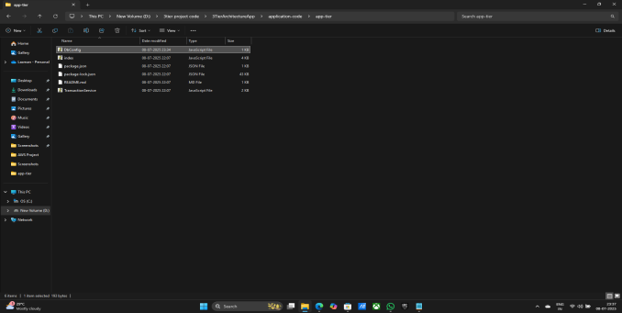

1. curl -o- https://raw.githubusercontent.com/avizway1/aws_3tier_architecture/main/install.sh | bash
2. source ~/.bashrc
3. nvm install 16
4. nvm use 16

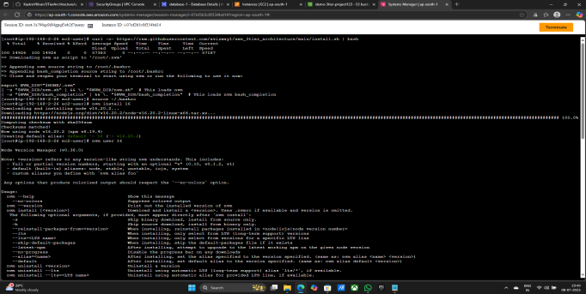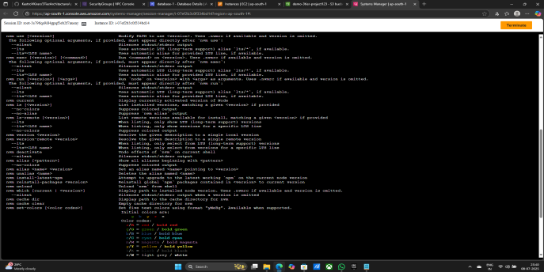

1. npm install -g pm2
2. pwd

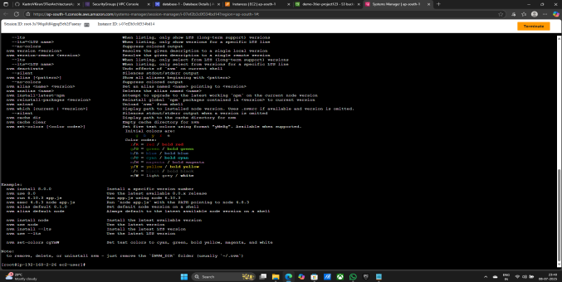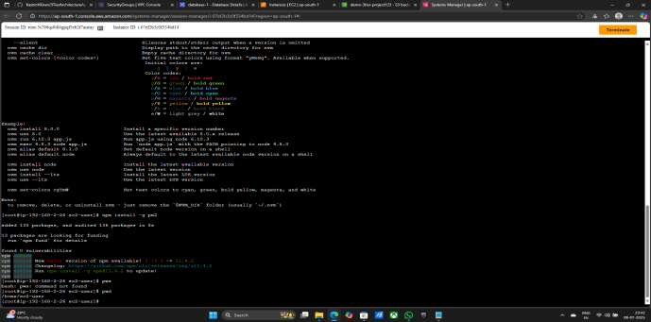

1. cd ..
2. cd ..
3. cd ~/
4. sudo aws s3 cp s3:/demo-3tier-project123/application-code/app-tier/ app-tier --recursive
5. ls
6. cd app-tier/
7. npm install
8. ls
9. pm2 start index.js

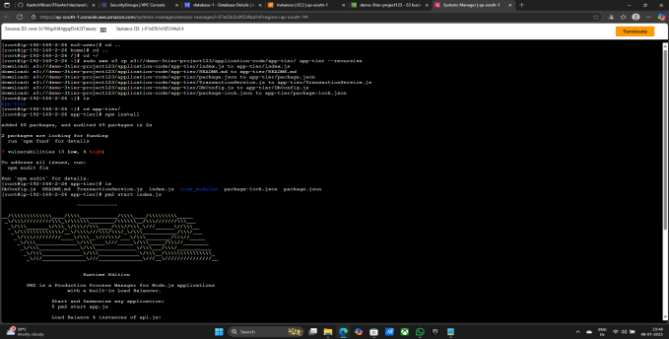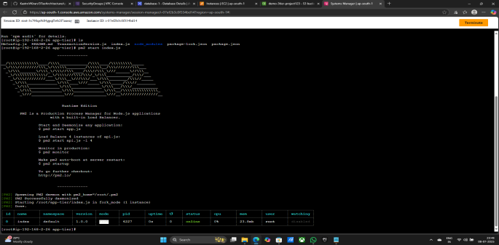

1. pm2 logs
2. pm2 startup
3. pm2 save
4. curl <http://localhost:4000/health>

**Now configration is complete**

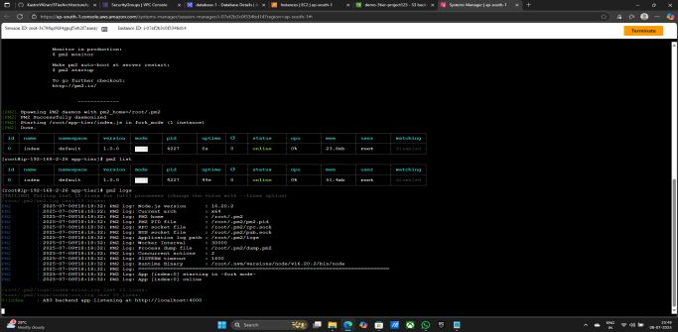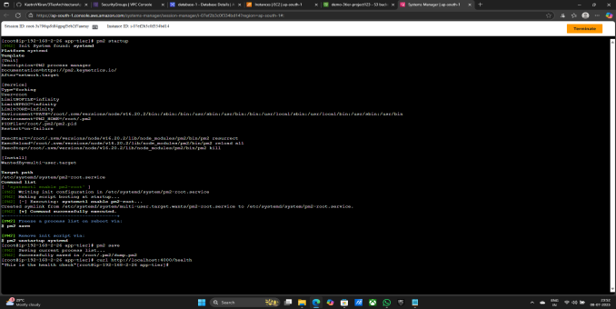

**Now Creating Target Group**

1. Click on Target Groups

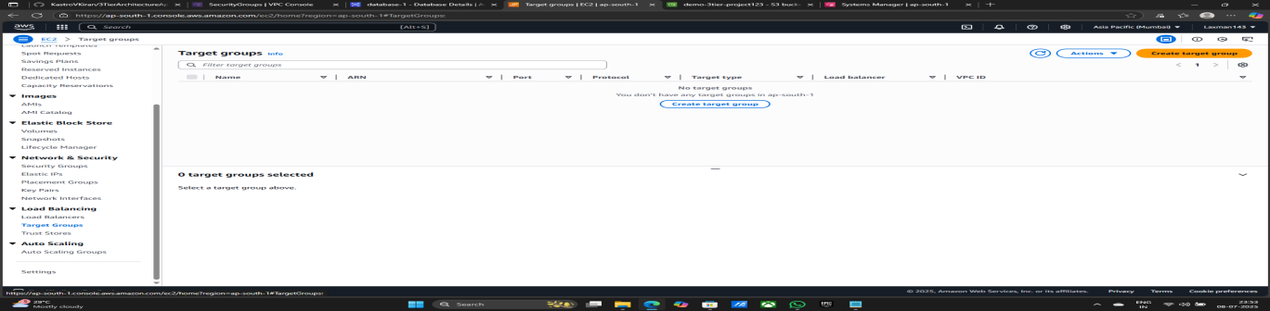

1. Target group name - App-Internal-TG

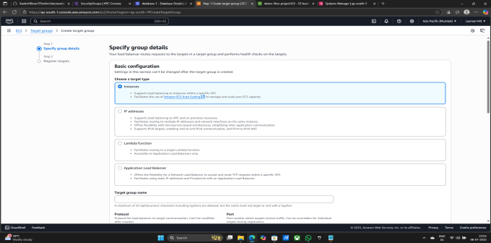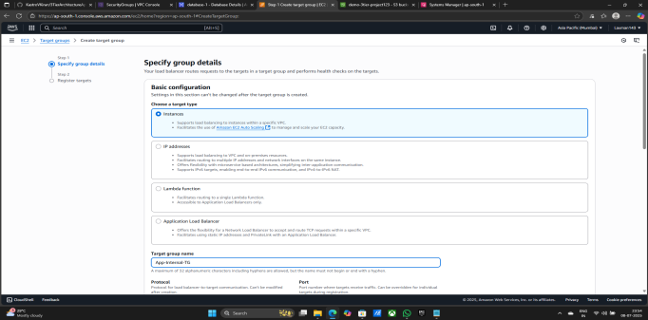

1. Protocoal - HTTP & Port - 4000
2. Select Created VPC - demo-vpc
3. Health check path - /health
4. Click on Next

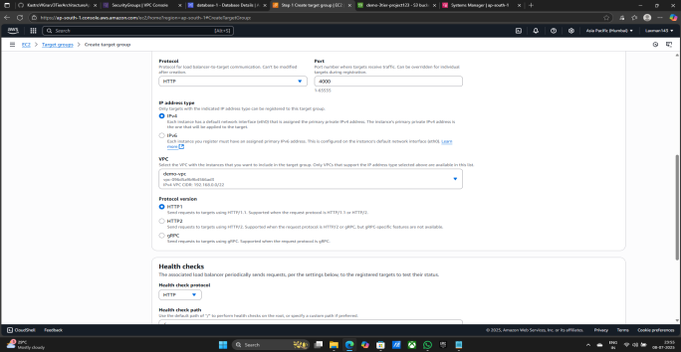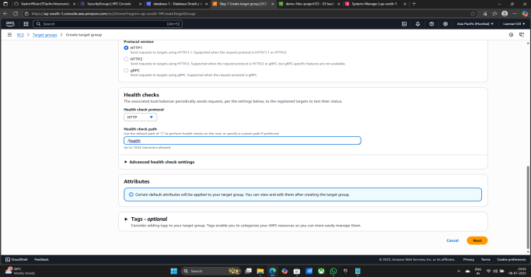

1. Select Created AppTierInstance
2. Click on Include as pending below
3. Click on Create target group

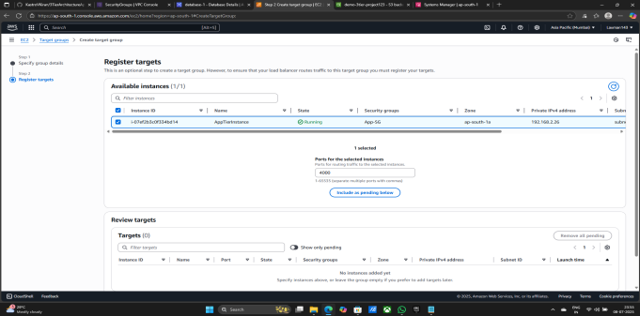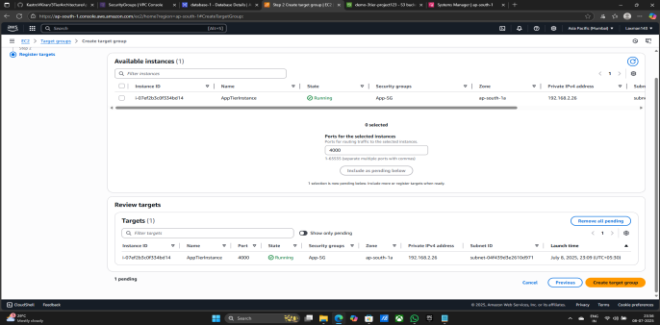

1. Target group is successfully created

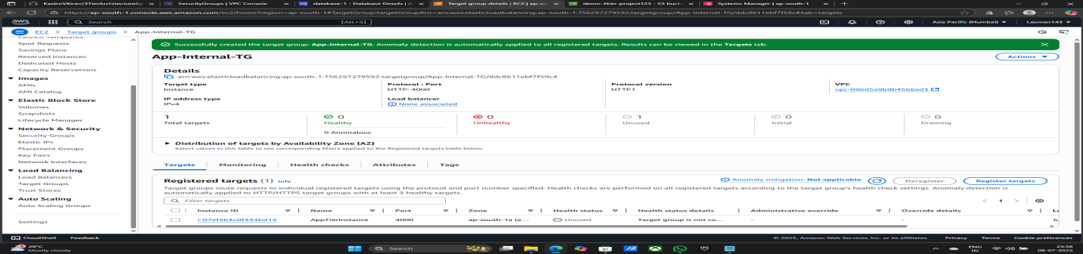

**Now Creatig Load balancers**

1. Click on Load balancers
2. Click on Create Application Load balancer

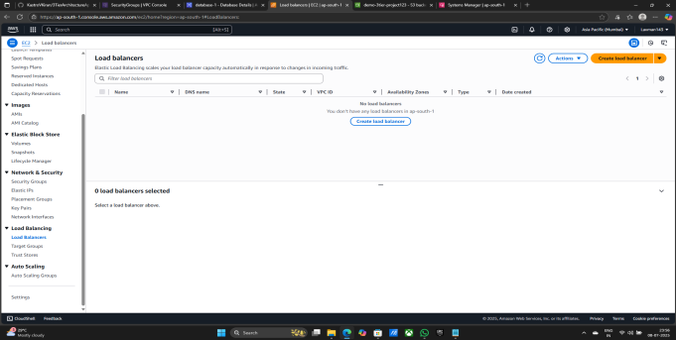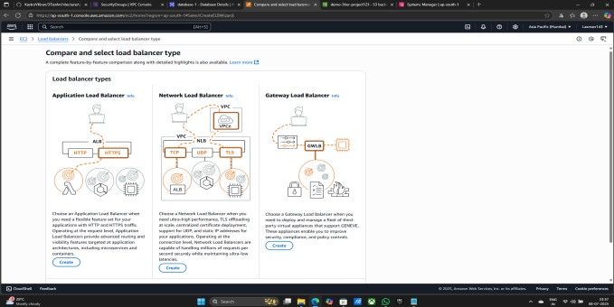

1. Give Load balancer name - App-Internal-LB
2. Select Created VPC - demo-vpc
3. Select Availability zones and subnets:- 1) demo-vpc-subnet-App1-ap-south-1a

2) demo-vpc-subnet-App2-ap-south-1b

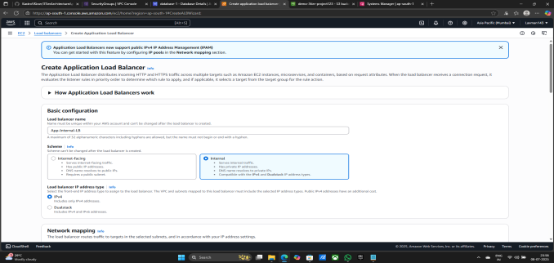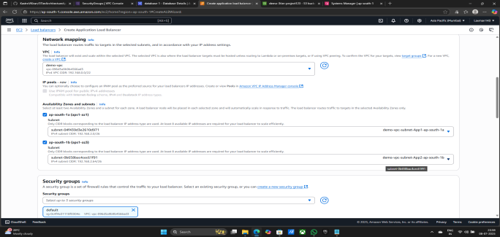

1. select created security group - Internal-ALB-SG
2. Listeners and routing - Prtocoal - HTTP & Port - 80
3. Default action - App-Internal-TG

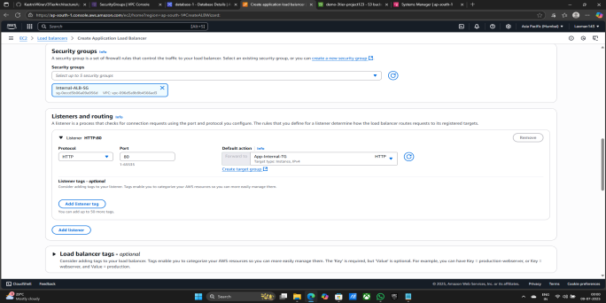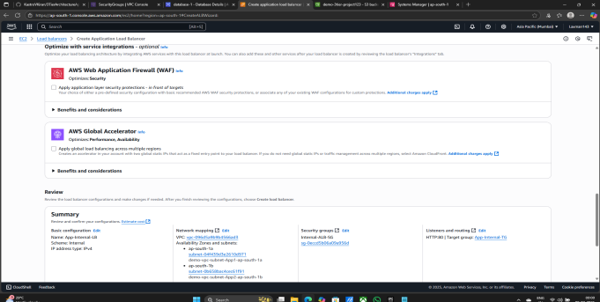

1. Click on Create load balancer
2. App-Internal-LB is successfully created

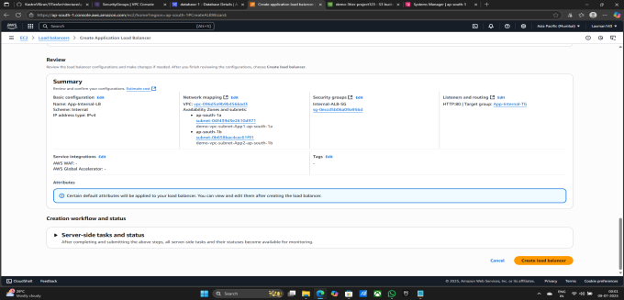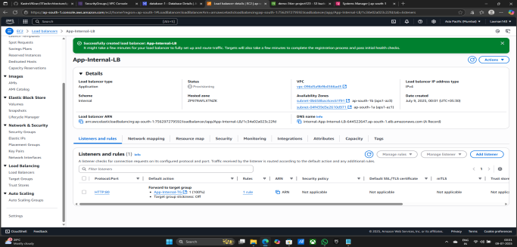

1. Go to the nginx.conf file
2. Copy the DNS name

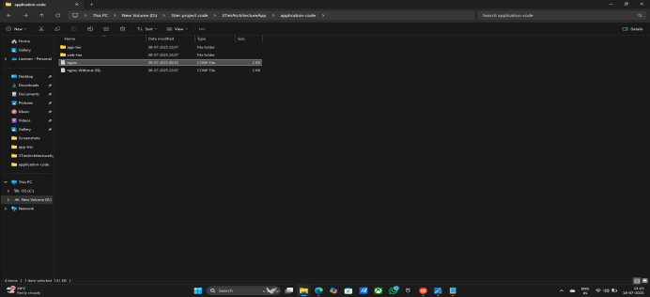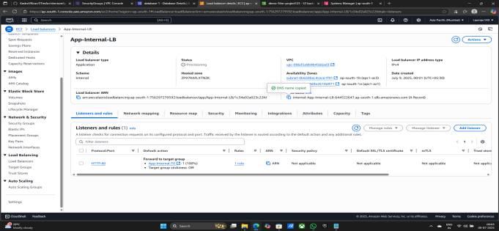

1. Change the last line in the nginx file:- proxy_pass <http://internal-App-Internal-LB-644522647.ap-south-1.elb.amazonaws.com:80/;>

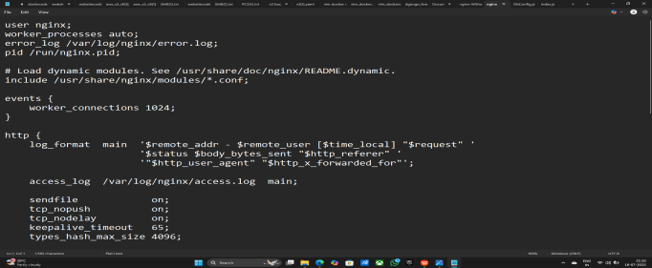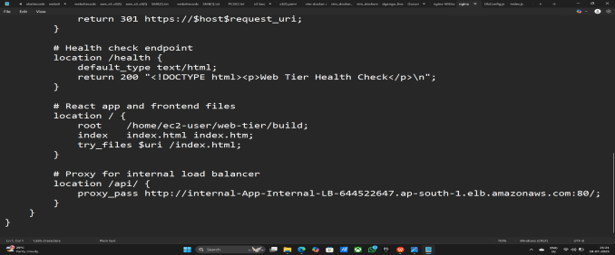

1. Go to Amazone S3 > Bucket > demo-3tier-project123 > application-code/
2. Click on nginx.conf
3. Now upload the updated nginx.conf file
4. Darg the file and upload here

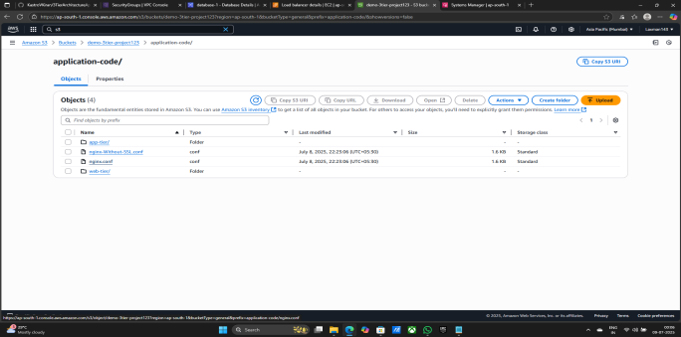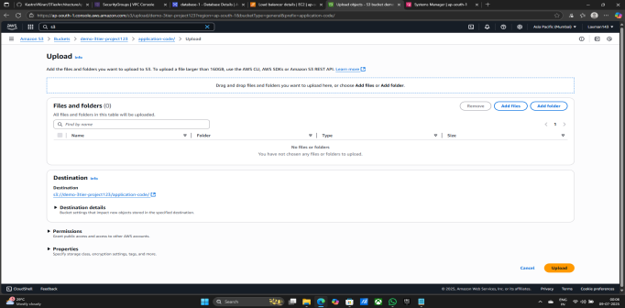

1. Click on upload
2. File is Upload succeeded Click on close

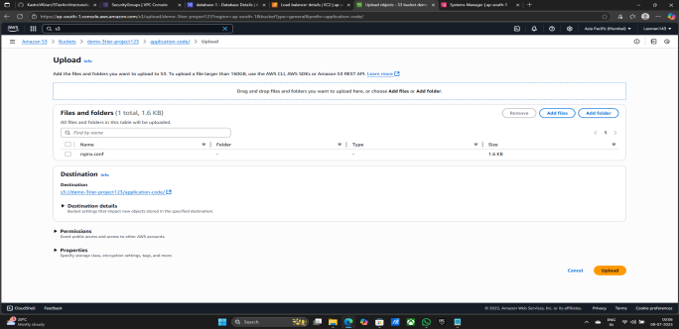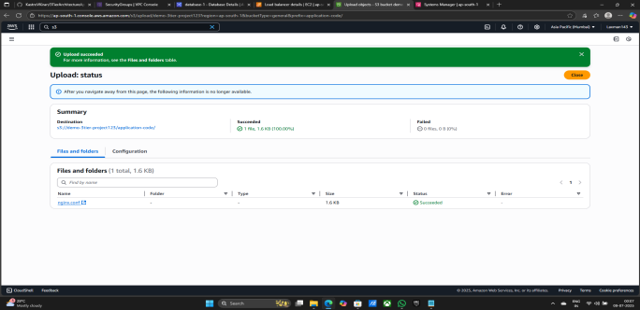

**Now Creating EC2 Instance for web-Tier-Instance**

1. Search ec2 & Click on EC2
2. Click on Launch Instance



1. Click on Launch Instances



1. Give the name of Instance - web-Tier-Instance

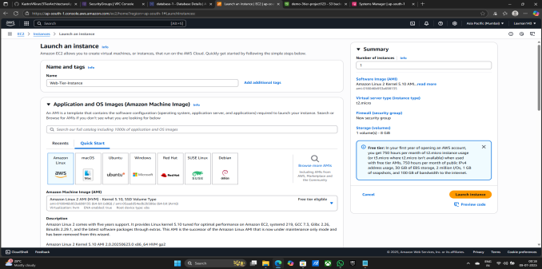

1. Key pair (login) - Proceed without a key pair (Not recommended) Default value
2. Select VPC - demo-vpc
3. Select subnet - demo-vpc-subnet-public1-ap-south-1a
4. Auto-assign public IP - Enable
5. Select common security groups - WEB-SG

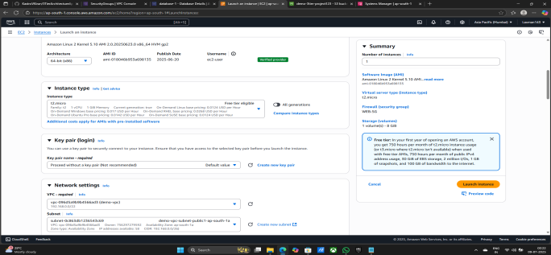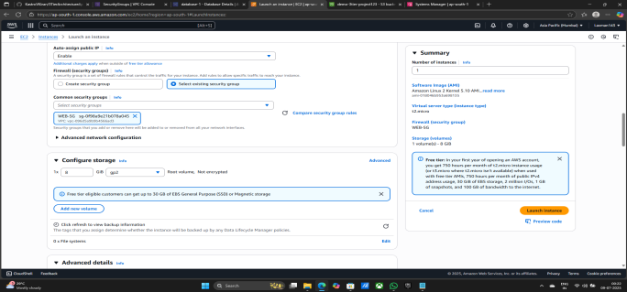

1. Click on Advanced details
2. IAM Instance profile - Demo-EC2-Role
3. Click on Launch Instance

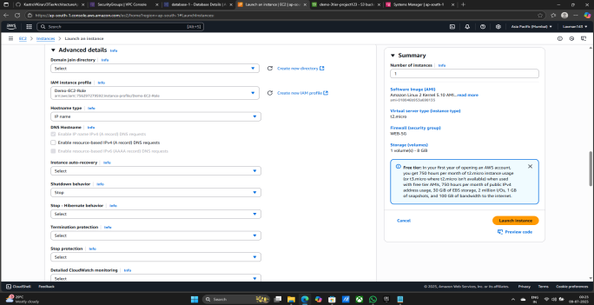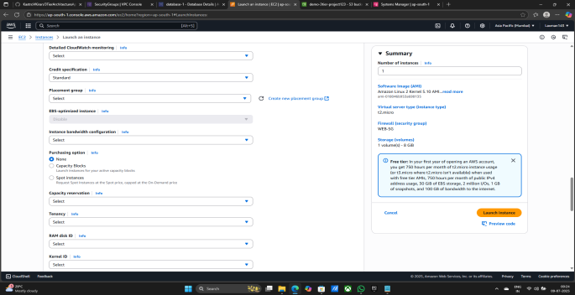

1. Instance is successfully created

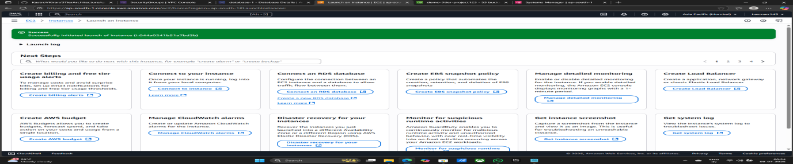

**Now start the Web-Tier-Instance Configration step by step**

1. Select the web-Tier-Instance
2. Click on connect
3. Again click on connect

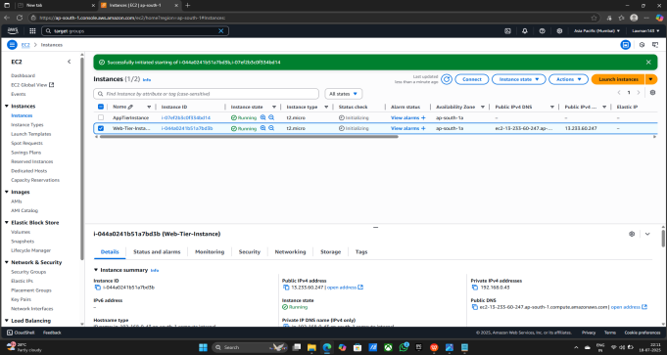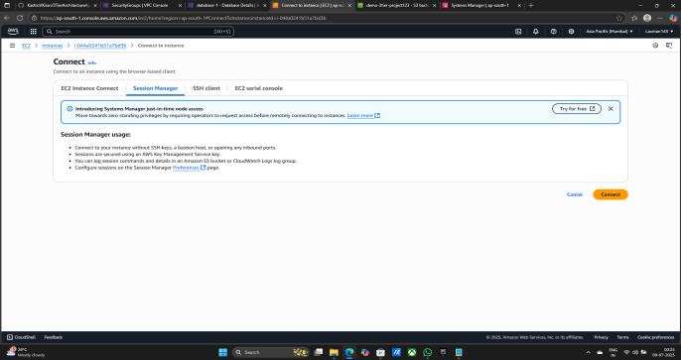

1. Commands configration - 1) sudo su

2) whoami

3) cd /home/ec2-user

4) curl -o- https://raw.githubusercontent.com/avizway1/aws_3tier_architecture/main/install.sh | bash

5) source ~/.bashrc

6) nvm install 16

7) nvm use 16

8) s3 cp s3://<S3BucketName>/application-code/app-tier/ app-tier --recursive:- (s3 cp s3://demo-3tier-project123/application-code/app-tier/ app-tier --recursive)

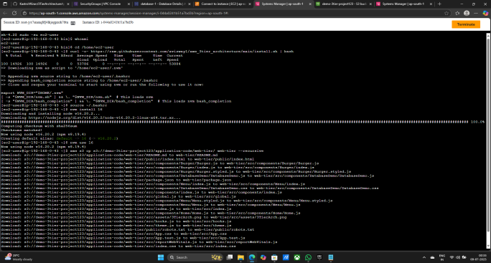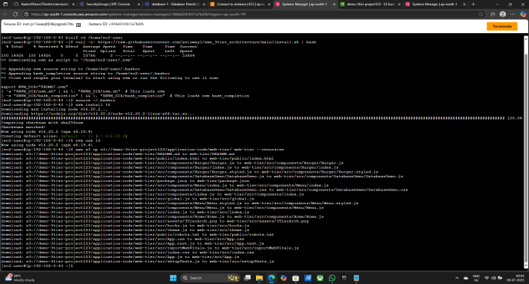

1. ls
2. cd /web-tier/
3. Npm install

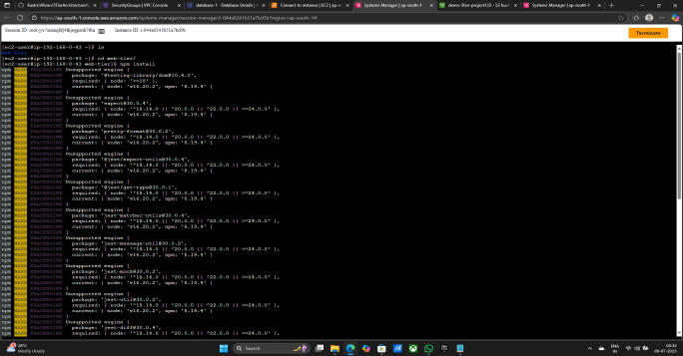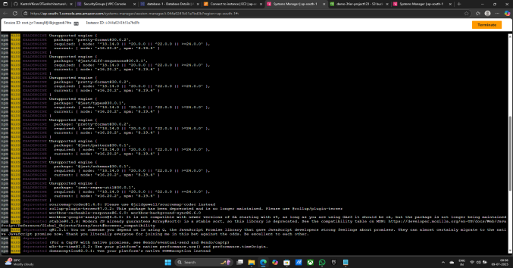

1. npm run build

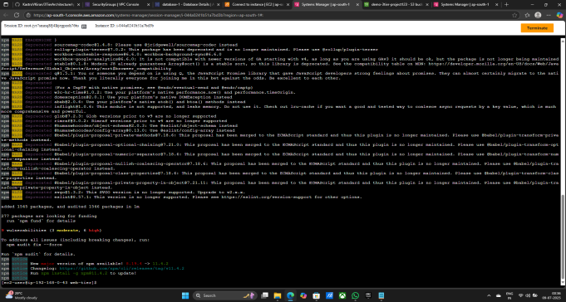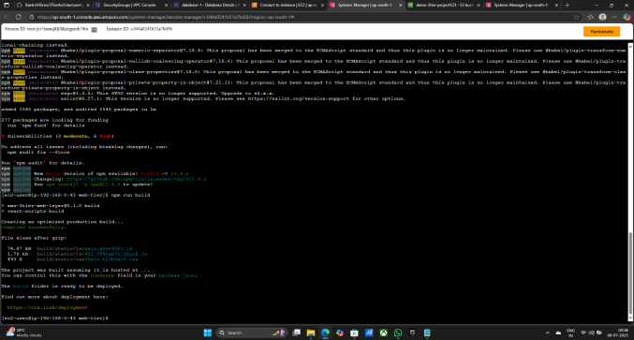

1. sudo amazon-linux-extras install nginx1 -y

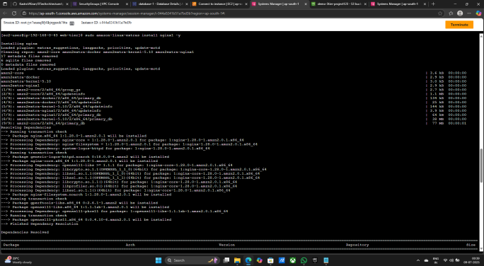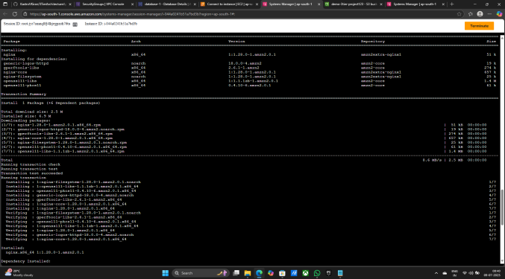

1. cd /etc/nginx
2. pwd
3. ls
4. sudo rm nginx.conf
5. sudo aws s3 cp s3://<S3 Bucker Name>/application-code/nginx.conf .:- (sudo aws s3 cp s3://demo-3tier-project123/application-code/nginx.conf .)

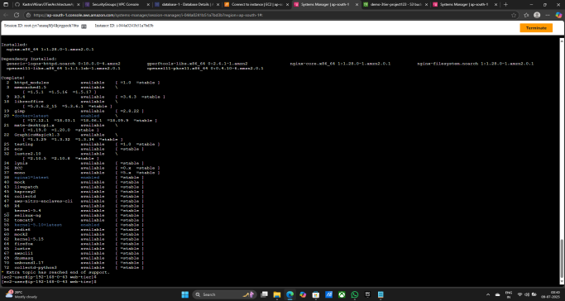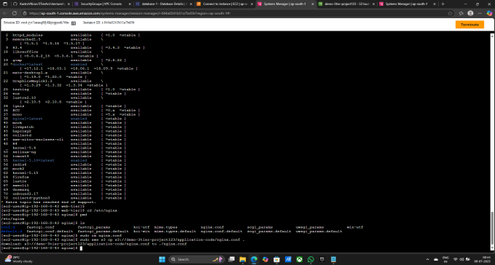

1. sudo service nginx restart
2. chmod -R 755 /home/ec2-user
3. sudo chkconfig nginx on

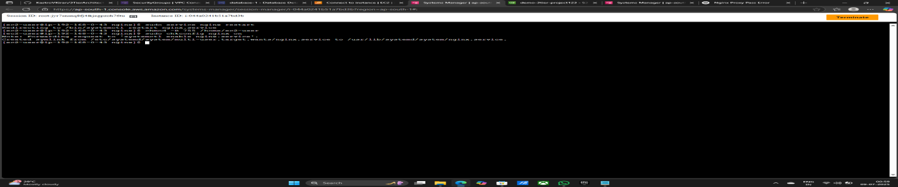

**Now Editing In instance security Edit Inboundrule**

1. Go to Instance
2. Select Web-Tier-Instance
3. Click on Security
4. Click on WEB-SG Security group

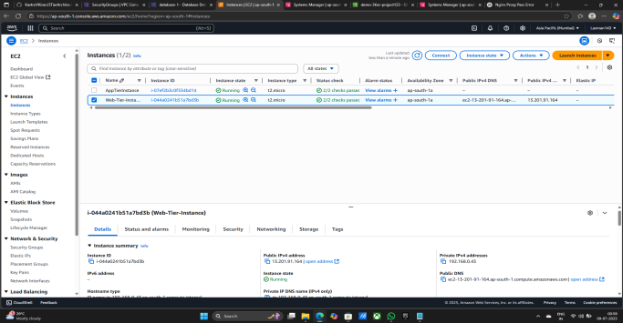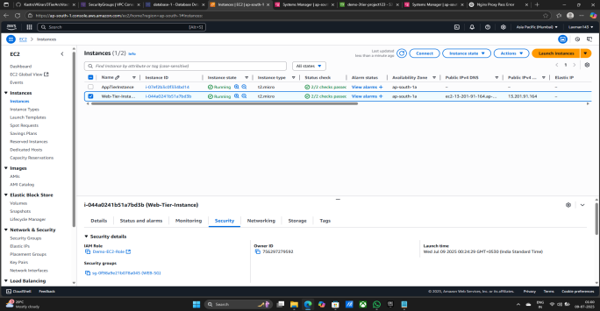

1. Click on Edit Inbound rules
2. Click on Add rule
3. Type - HTTP & Source - 0.0.0.0/0
4. Click on save rules

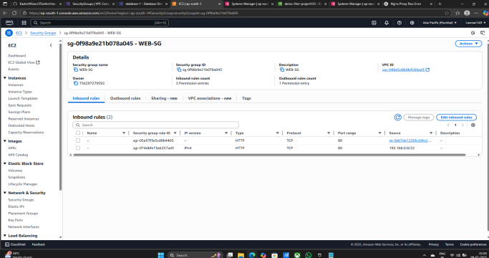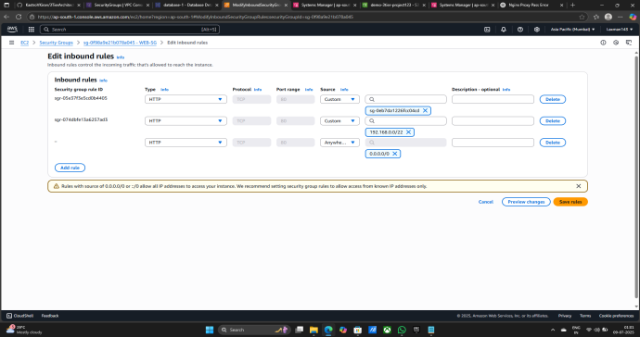

1. Inbound security group rules successfully modified on security Group
2. Again go to Instane
3. Select Web-Tier-Instance
4. Copy the public ip - 13.201.91.164

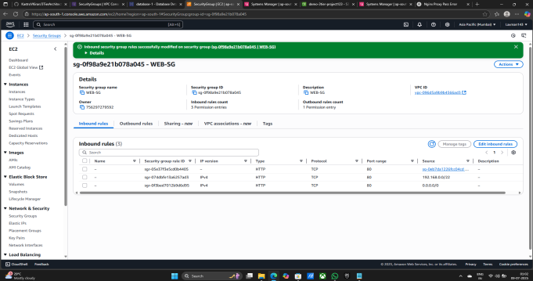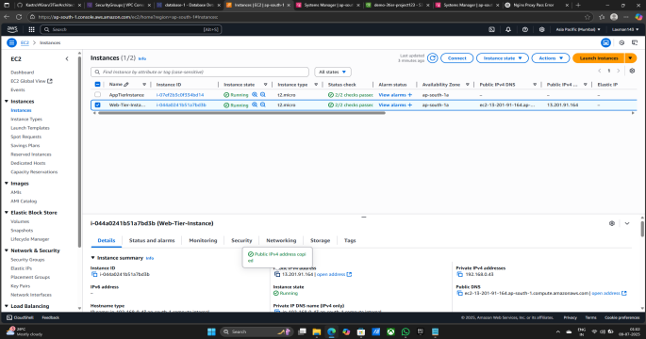

1. Open the Browser
2. Paste the Public ip - 13.201.91.164
3. Site is open successfully
4. Click on Left hand upper side three lines

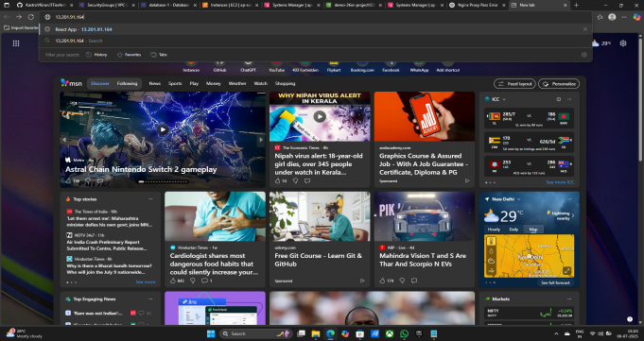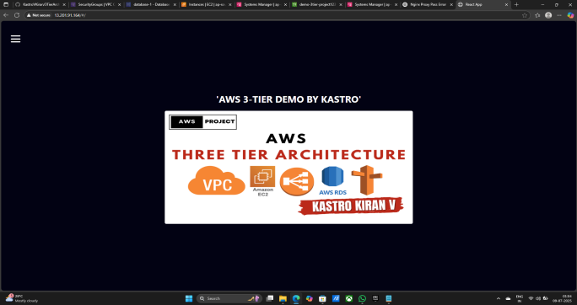

1. Now click on DB DEMO
2. Add data Easily - 1) AMMOUNT -100000

2) DESC - AWS

xviii) Click on ID - ADD data is add successfully

xix) Site is working Properly

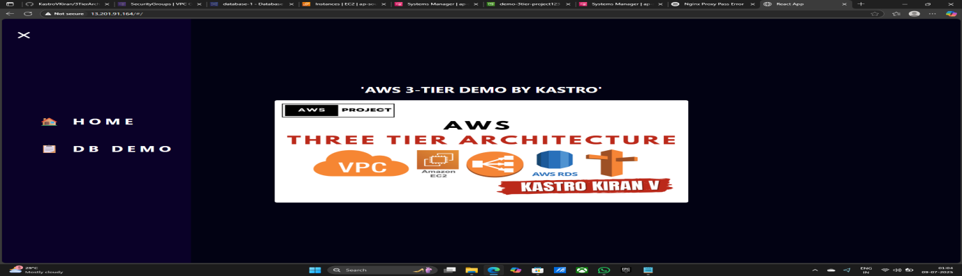

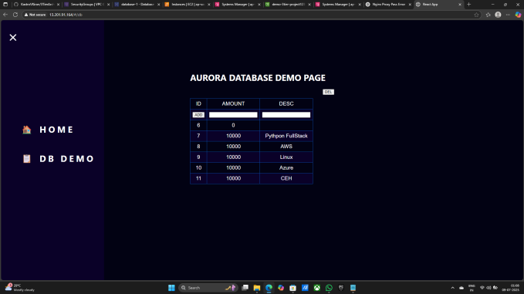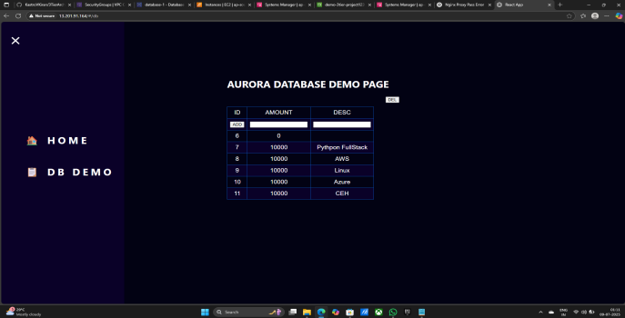

**Now Project is complete but I do Some more things like Attach Certificate and domain.**

**Now Creating New target Group**

1. Go to EC2
2. Click on Target Groups
3. Click on Create target group

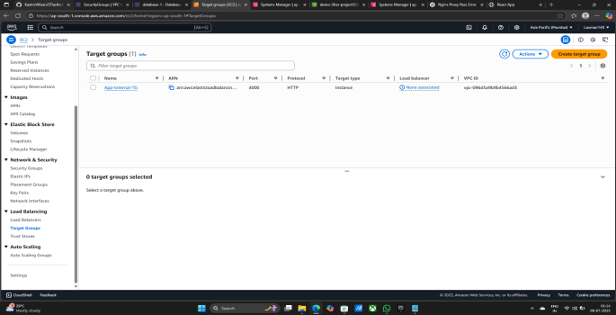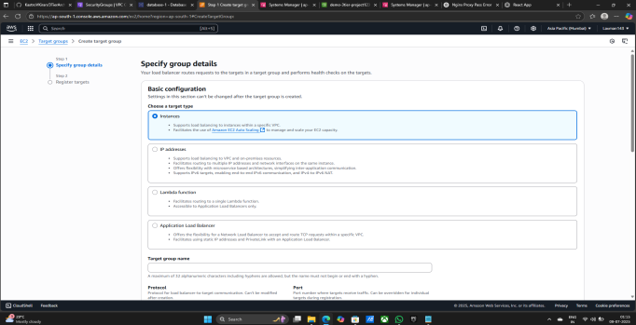

1. Target group name - External:-Web-TG
2. Select VPC - demo-vpc
3. Click on next

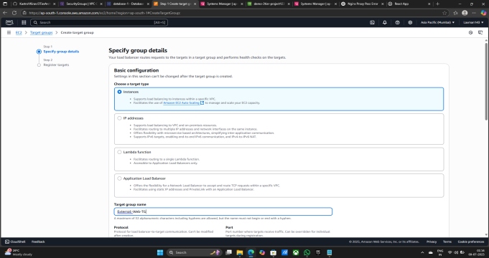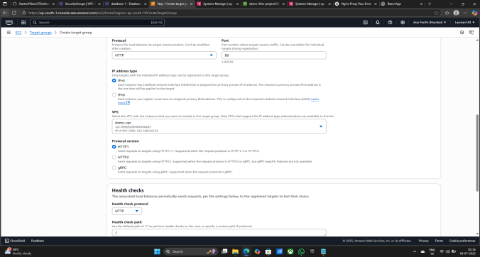

1. Select Web-Tier-Instance
2. Click on Include as a pending below
3. Click on Create target group

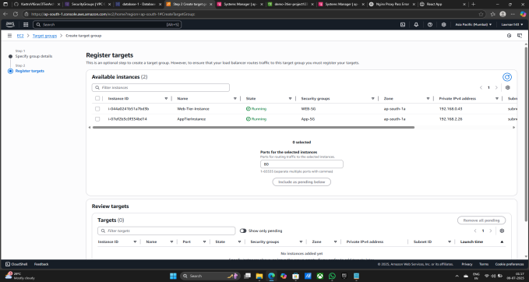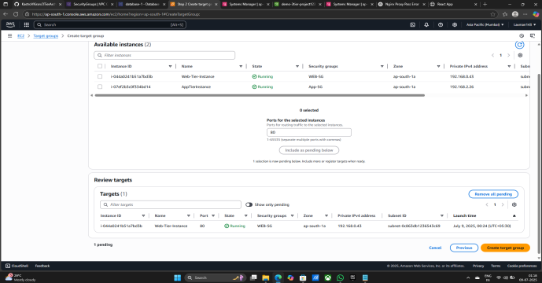

1. Successfully created Target group
2. Go to Load balancer
3. Click on Create load balancer

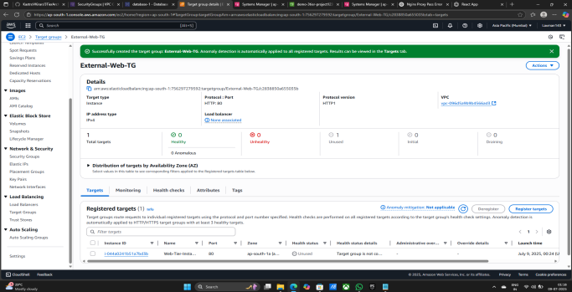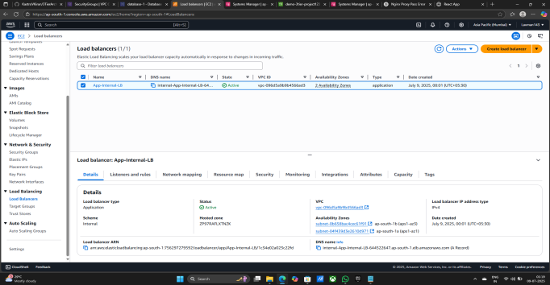

1. Click on Create application Load Balancer
2. Give Load balancer name - External-Web-ALB
3. Click on Internet-facing

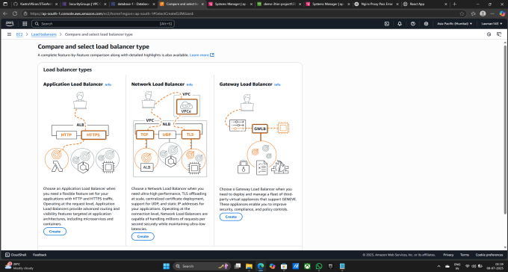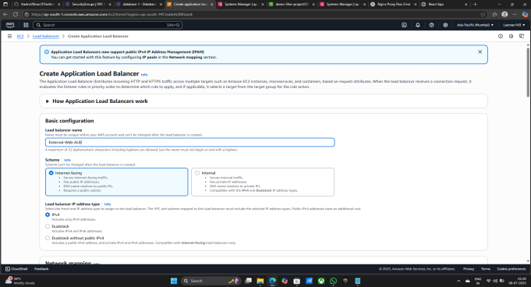

1. Select VPC - demo-vpc
2. Availibility zones and subnets- 1) demo-vpc-subnet-public1-ap-south-1a

2) demo-vpc-subnet-public2-ap-south-1b

1. Select Security groups - Web-ALB-SG
2. Listeners and routing - Protocoal - HTTP & Port - 80
3. Default action - External-Web-TG

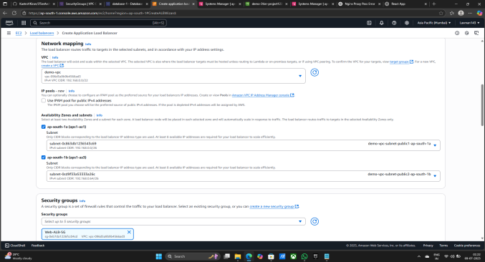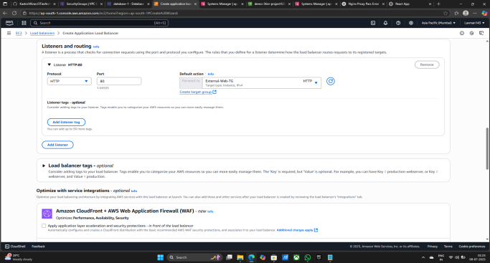

1. Click on Create load balancer
2. Load balancer Created Successfully

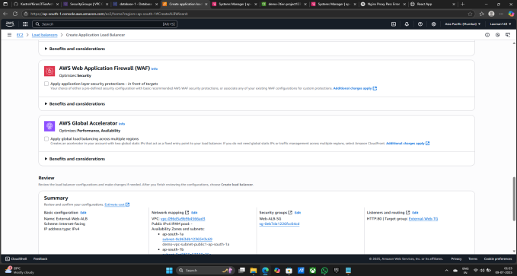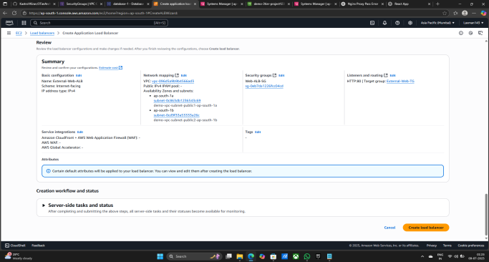

**Now Creating Route 53 to attach DNS (Domain Name Server)**

1. Search route 53 in search bar
2. Click on Route 53

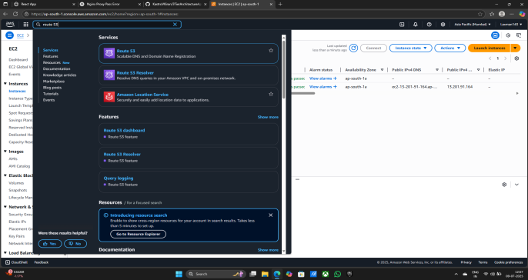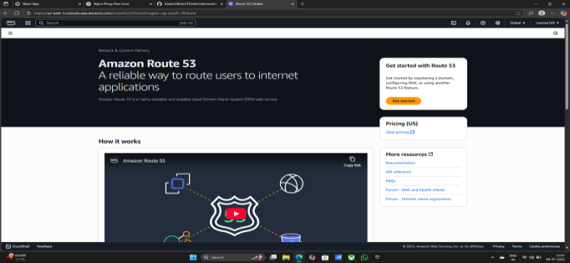

1. Click on Create hosted zones
2. Click on Get started

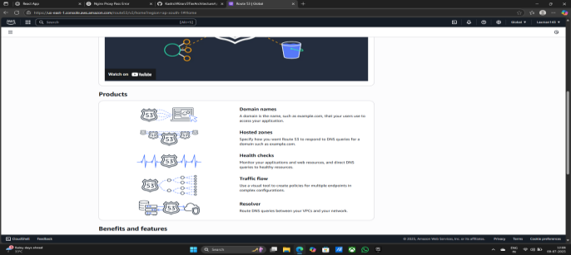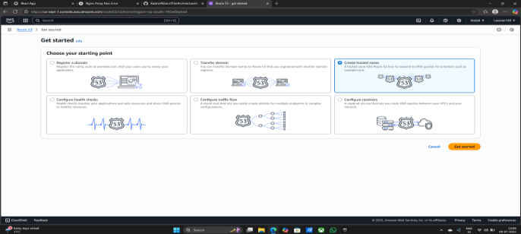

1. Give your Domain name - ajaycloud.site
2. Click on Create hosted zone

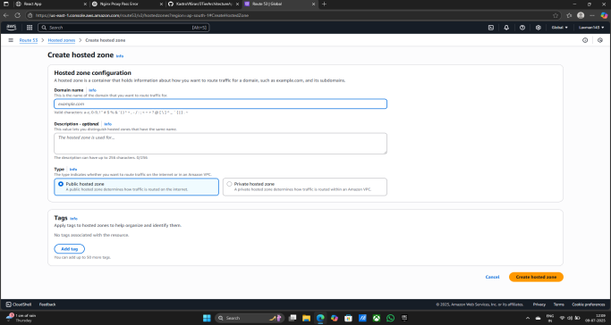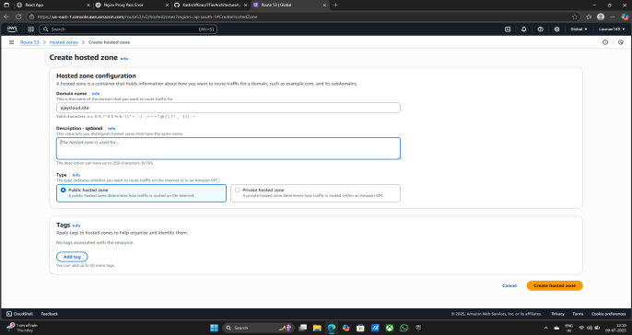

1. Hosted zone ajaycloud.site is Successfully created

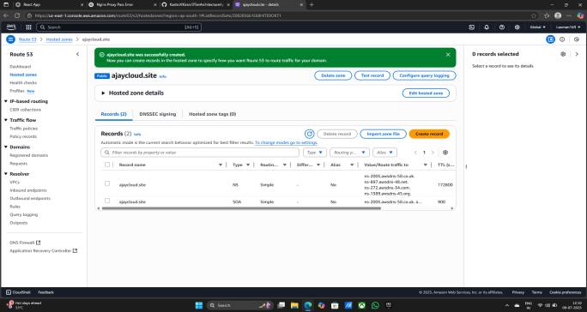

**Now Go on the domain site Where you wont to buy Like GoDaddy**

1. Open the browser
2. Search GoDaddy site
3. Click on first link

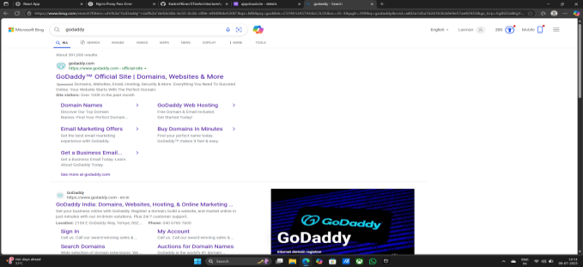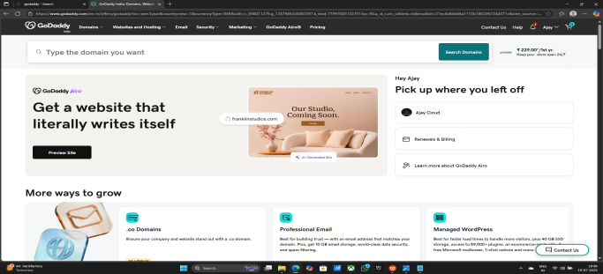

1. Create Account on the GoDaddy & Sign in
2. After Creating Account Buy the domain

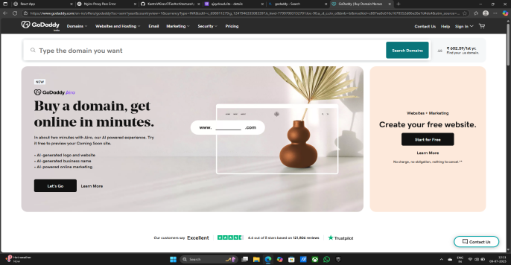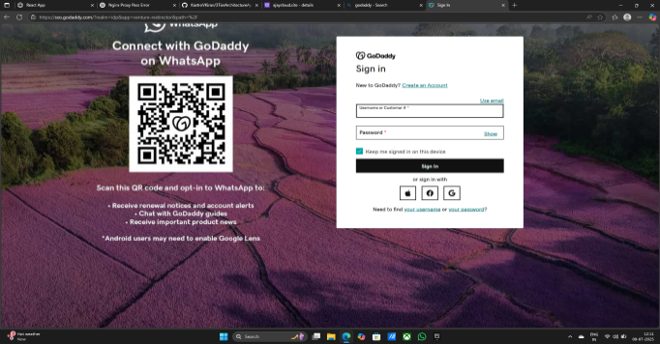

1. I am buying domain Like ajaycloud.site
2. You see the Dashboard like this after the buying domain

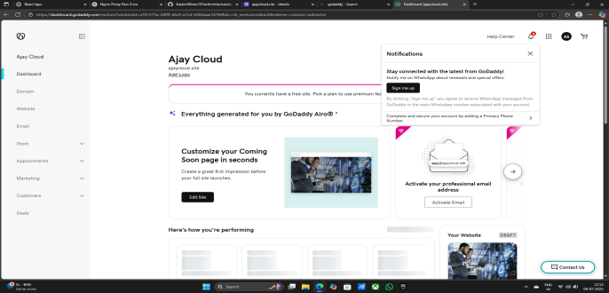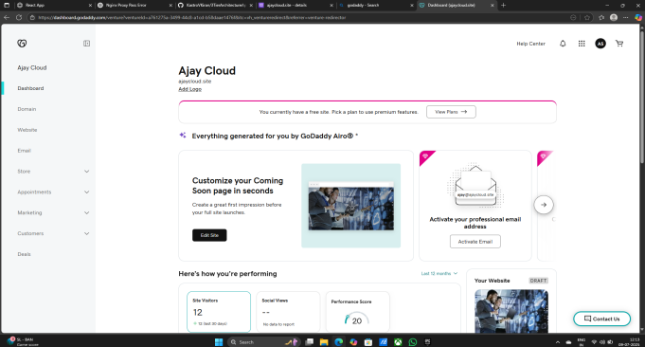

1. Click on Domain
2. Click on DNS
3. Click on Nameservers

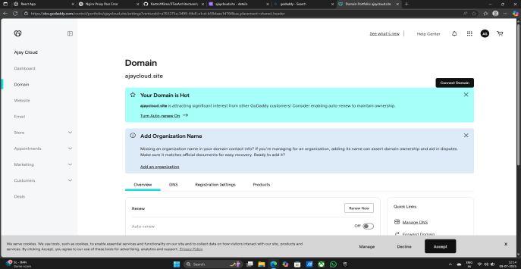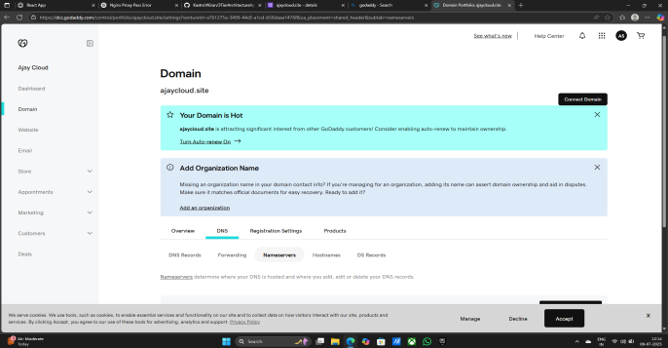

1. Click on Change Nameservers

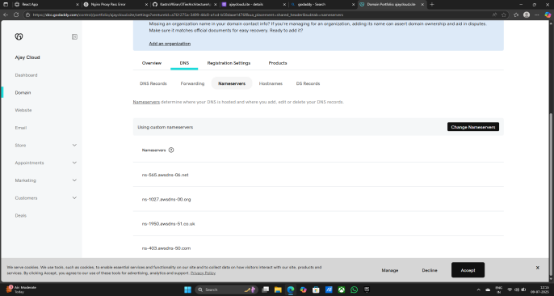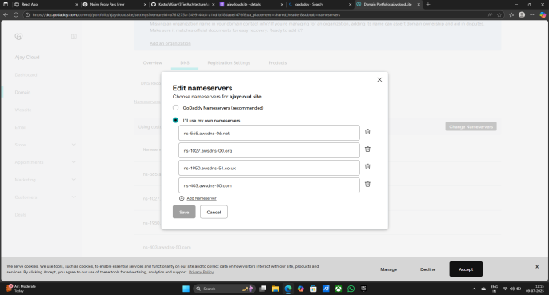

1. Copy all the Nameservers from Create hosted zone
2. Change all Namesercers one by one in domain Edit nameservers
3. After changing Nameservers Click on save

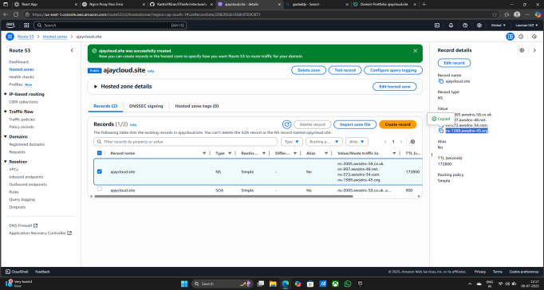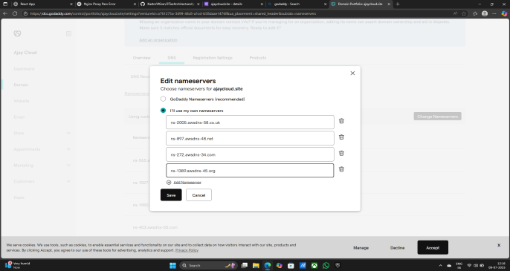

1. Click on continue
2. DNS Nameservers Changed Successfully

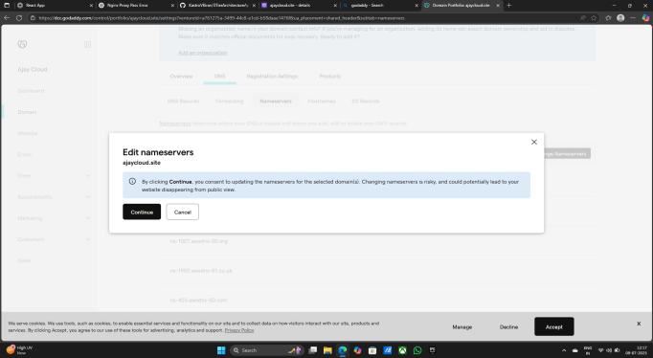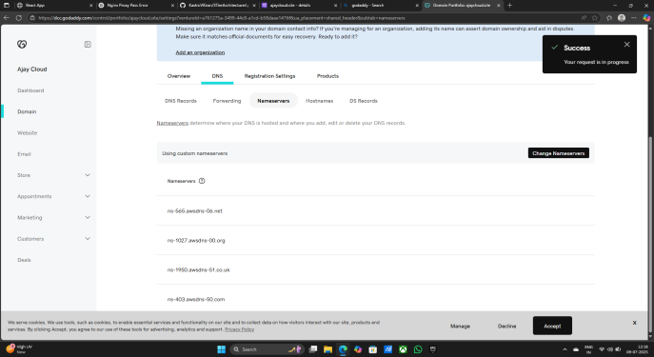

**Now Creting record**

1. Go to Created Hosted zone - ajaycloud.site
2. Click on ajaycloud.site
3. Click on Create record

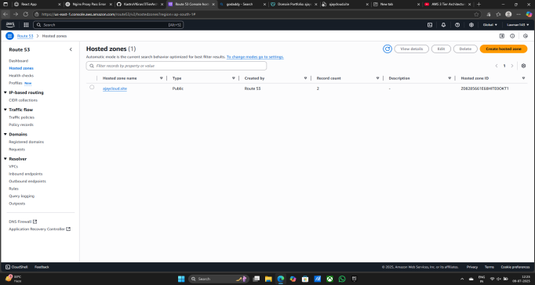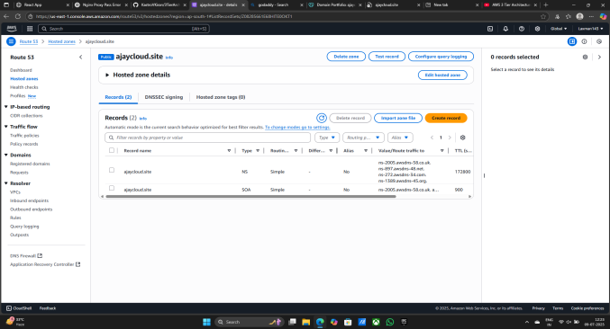

1. Record type - A - Routes traffic to an IPv4 address and some AWS resources
2. On Alias
3. Route trafficto - 1) Alias to Application and Classic Load Balancer

2) Asia Pacfic (Mumbai)

3) dualstack.External-Web-ALB-1334855993.ap-south-1.elb.amazonaws.com

1. Routing policy - Simple routing
2. Click on Create records

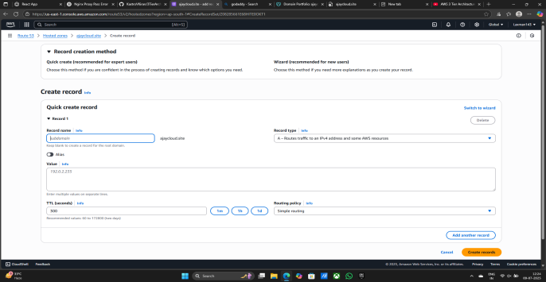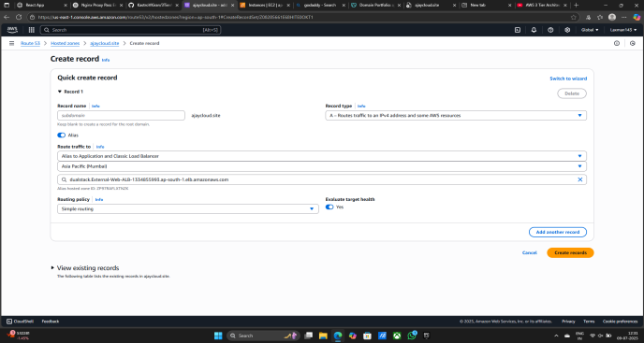

1. Records for ajaycloud.site is Successfully created

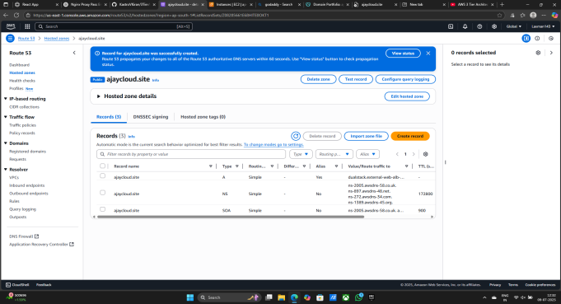

**Now Creating Certificate Manager for Site is secure**

1. Search Certificate manager on search bar
2. Click on Certificate Manager

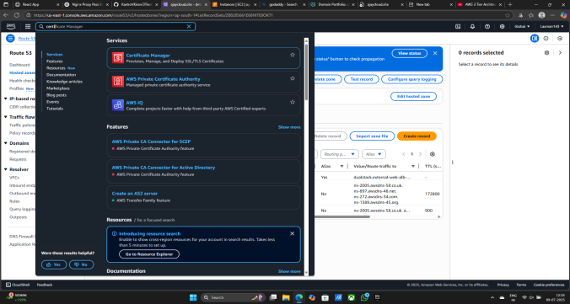

1. Click on Request a certificate
2. Select a Request a public certificate

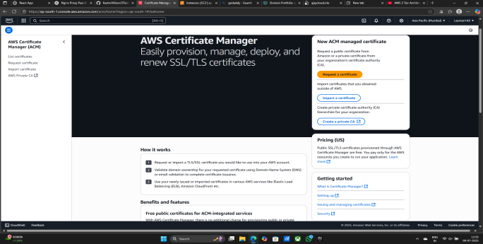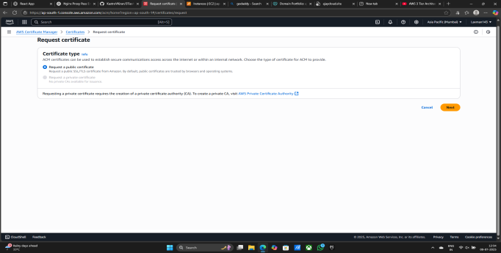

1. Give Fully qualified domain name - ajaycloud.site

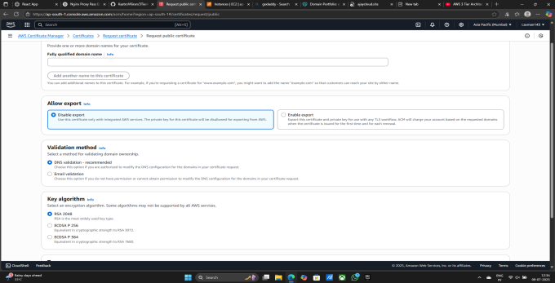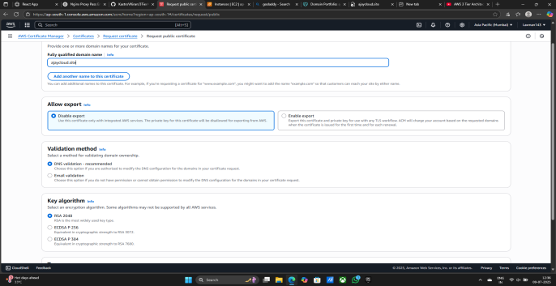

1. Click on Request
2. Successfully requested certificate

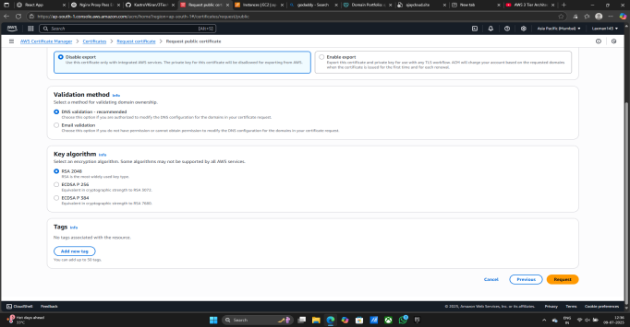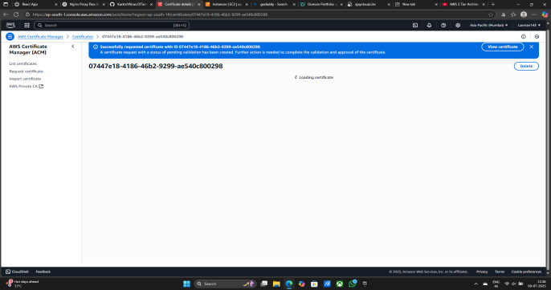

1. Click on Create records in Route 53
2. Select the ajaycloud.site
3. Click on Create records

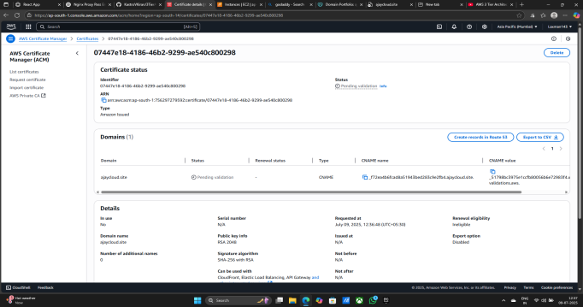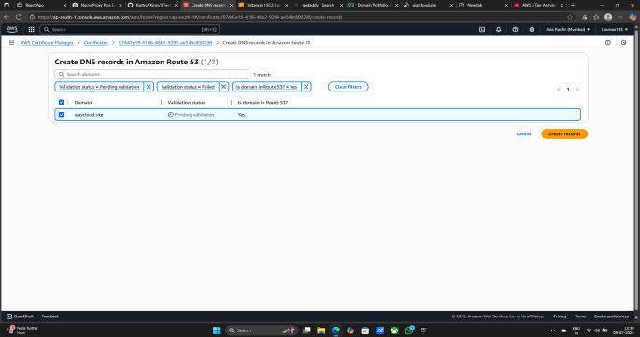

1. Successfully Created DNS records
2. Certificate status is Pending taking 10 to 20 minutes maximum

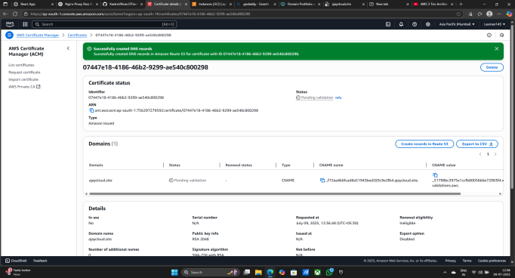

**Now Add listner in Load balancer (External-Web-ALB)**

1. Click on External-Web-ALB
2. Click on Add listener

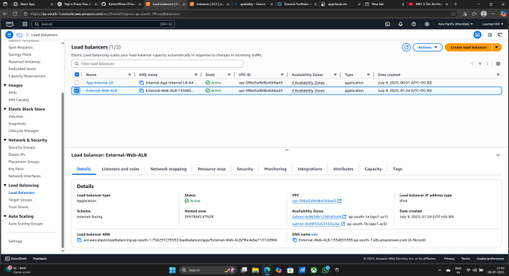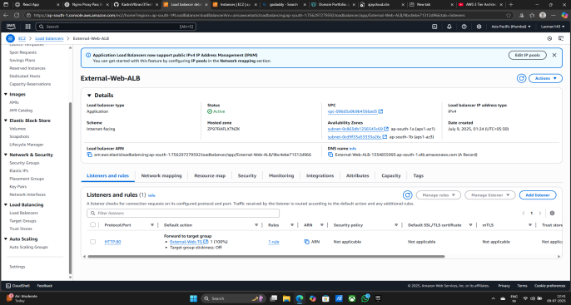

1. Listener configuration - Protocoal - HTTPS & Port - 443
2. Target group - External-Web-TG

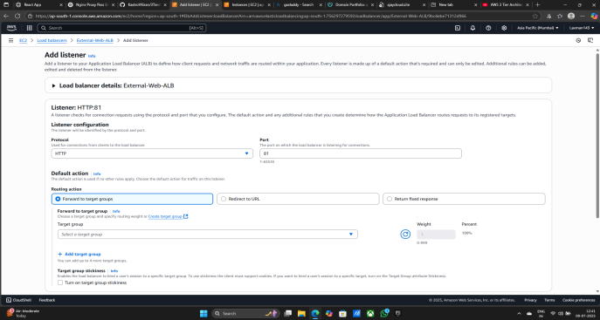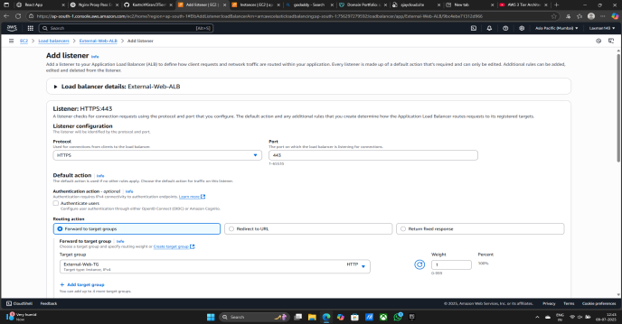

1. Certificate (from ACM) - ajaycloud.site

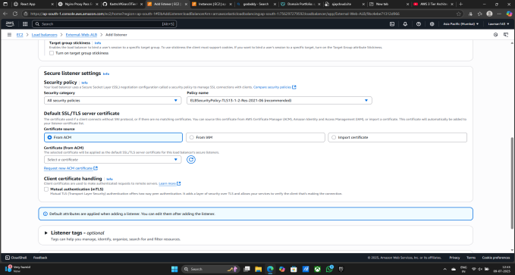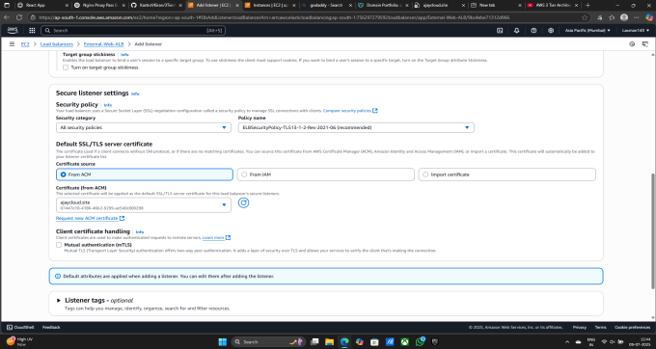

1. Click on Add
2. Listener is Successfully created

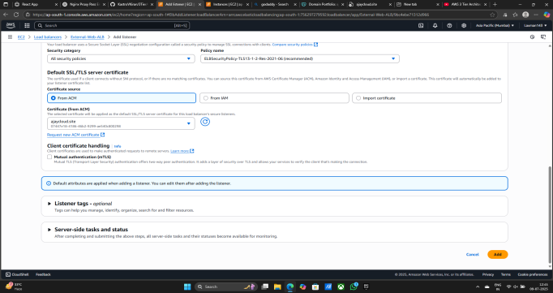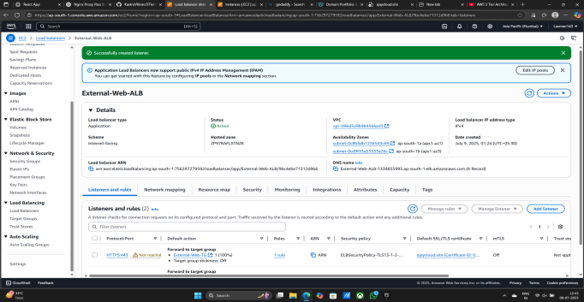

1. Listener and rules - HTTPS is Successfully Created

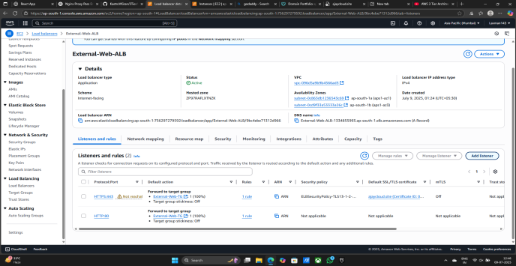

**Now Edit Security Group**

1. Go to EC2 Insatnce
2. Click on Security group
3. Click on Web-ALB-SG
4. Click on Edit inbound rules

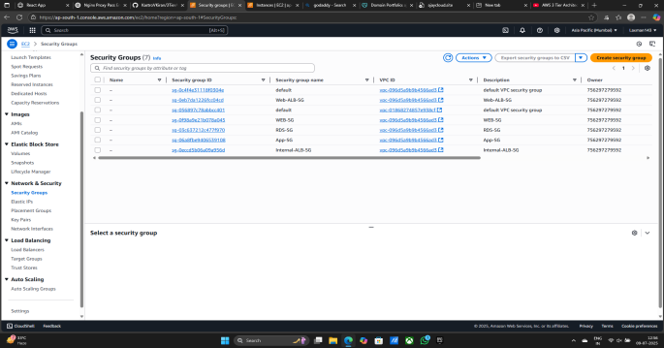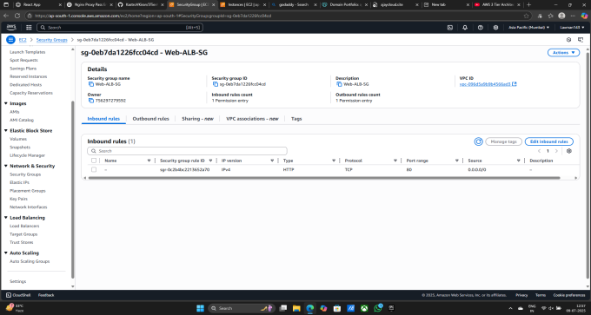

1. Click on Add rule
2. Type - HTTPS & Source - Anywhere - 0.0.0.0/0
3. Click on Save rules
4. Rule is Saved Successfully

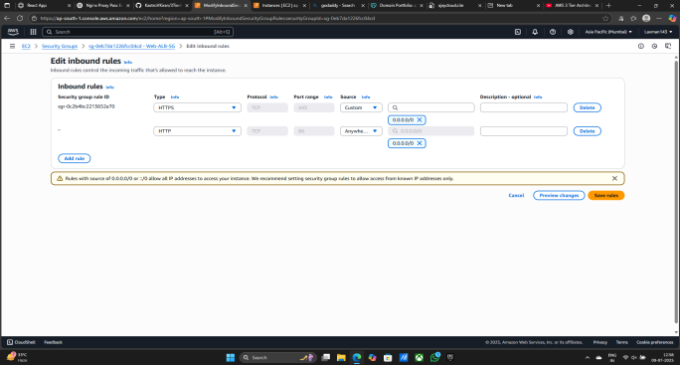

**Now Check the Site is working properly and Secure**

1. Open the Browser
2. Search the Site with the help of domain
3. https://ajaycloud.site/
4. Site is open Successfully open with Secure
5. Click on left upper side three lines and click on DB DEMO

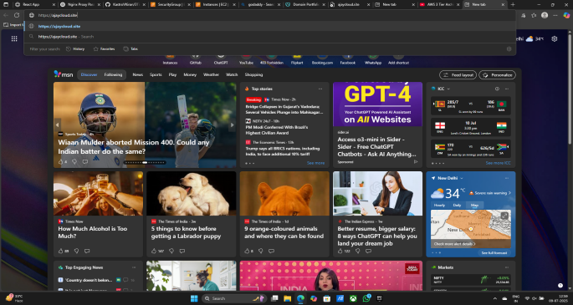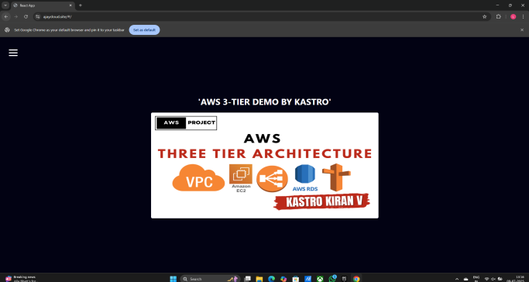

1. AMOUNT - 10000 & DESC - GCP
2. Click on ADD
3. AMOUNT - 10000 & DESC - AZJURE
4. Click on ADD
5. Data is Add and Delete Successfully

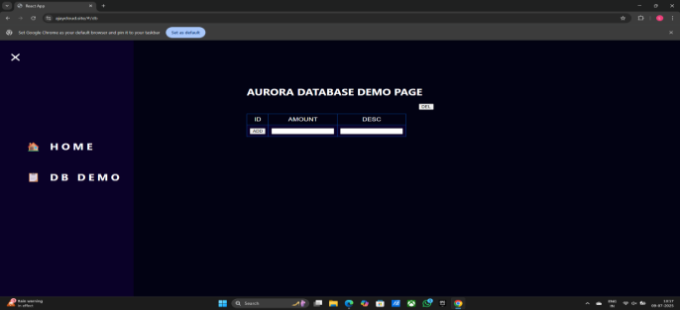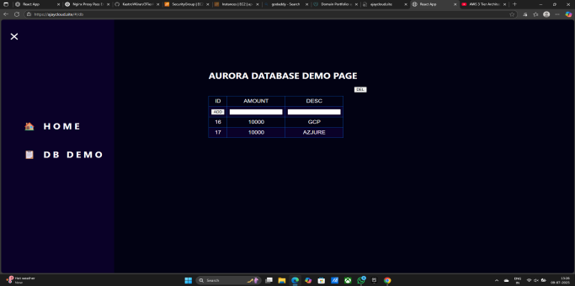

**Now create AMI for Both Instances**

1. Go to EC2 instance
2. Select AppTierInstance
3. Click on Action
4. Click on Image and templates
5. Click on Create image

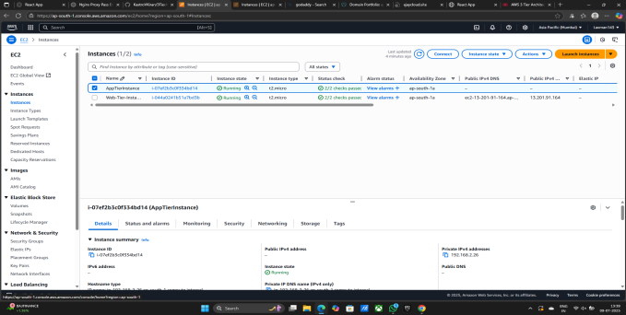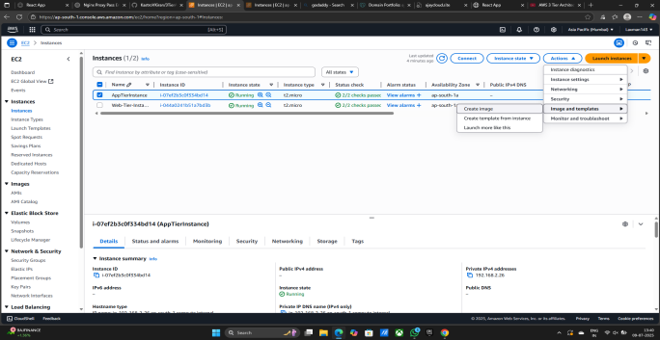

1. Give Image name - App-Tier-AMI
2. Give Image description - App-Tier-AMI

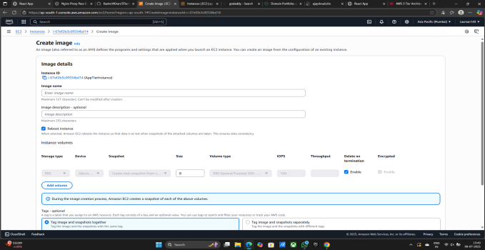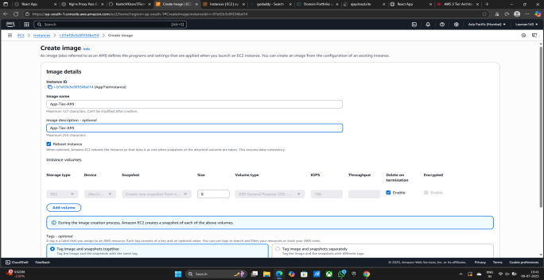

1. Click on Create image
2. Image is Created Successfully Created

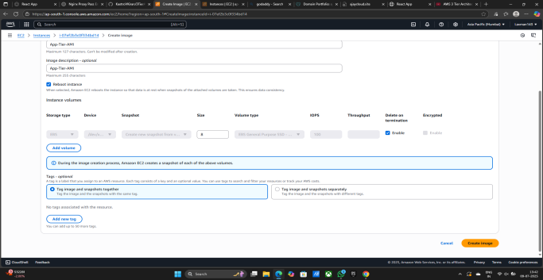

**Now Creating Second AMI for Web-Tier-AMI**

1. Go to EC2 instance
2. Select WebTierInstance

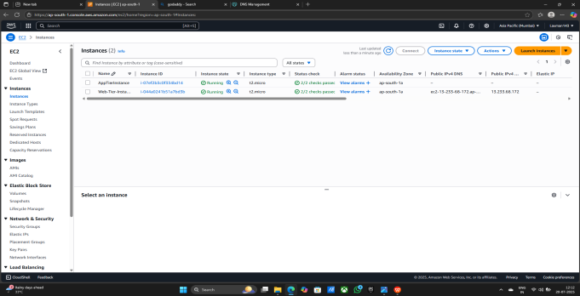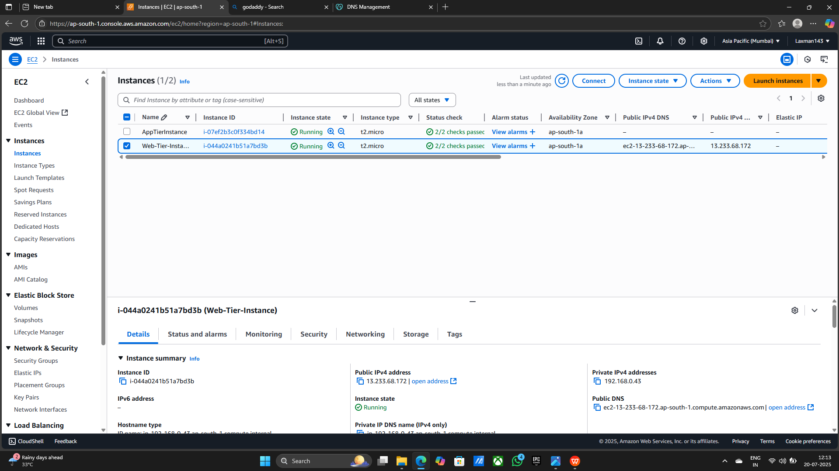

1. Click on Action
2. Click on Image and templates
3. Click on Create image

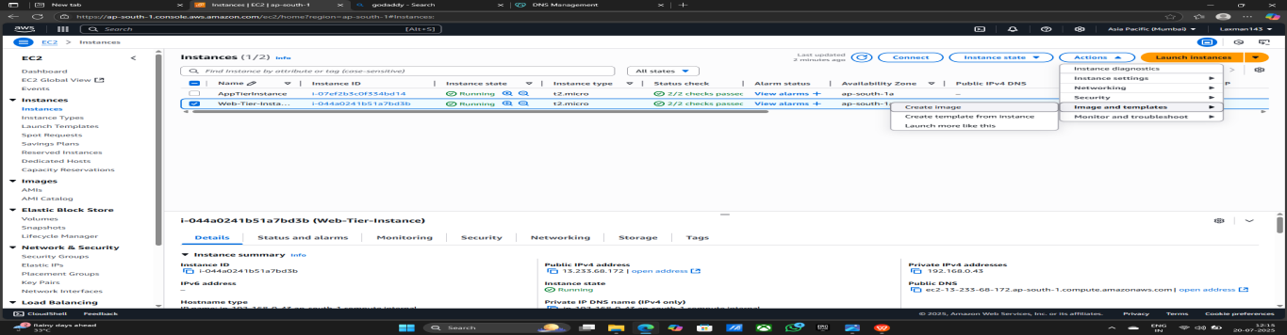

1. Give Image name - Web-Tier-AMI
2. Give Image description - Web-Tier-AMI
3. Click on Create image
4. Image is Created Successfully Created

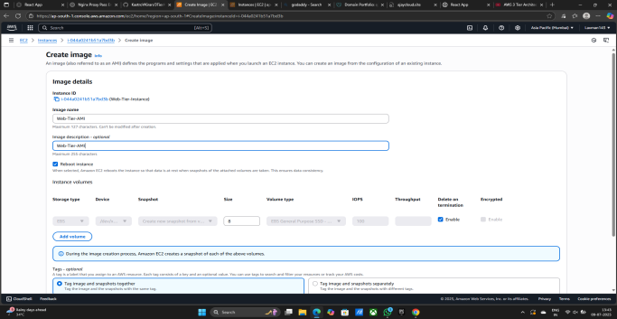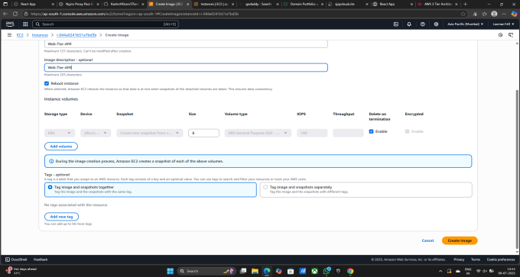

**Now creating Template from AMI**

1. Go to EC2 Instance
2. Click on AMIs
3. Click on Create launch template

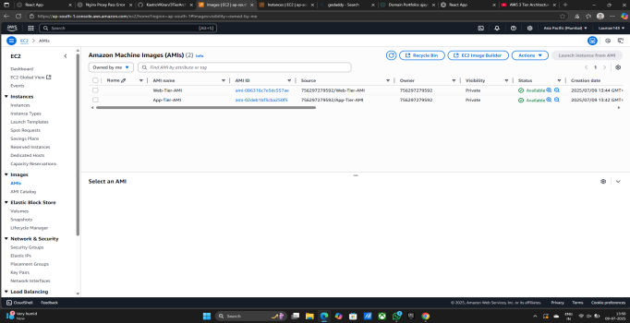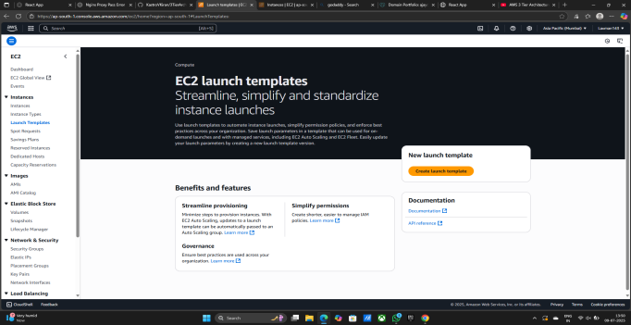

1. Give Launch template name - App-Tier-LT
2. Template version description - V1
3. Check mark the Auto Scaling guidance
4. Click on My AMIs - Owned by me
5. Select Amazon Machine Image (AMI) - App-Tier-AMI

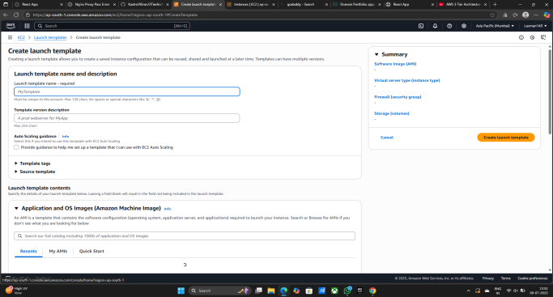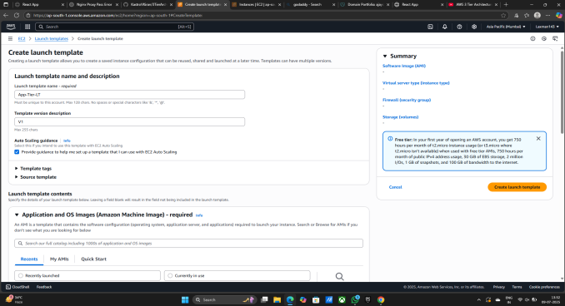

1. Firewall (security groups) - Select existing security group
2. Security groups - App-SG

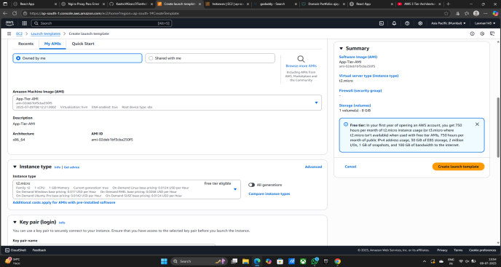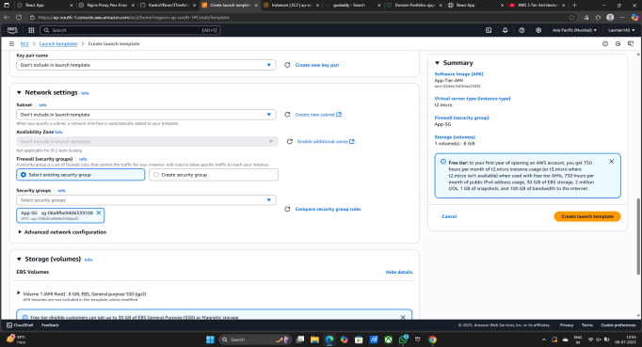

1. Click on Advanced details
2. IMA Instance profile - Demo-EC2-Role
3. Click on Create launch template
4. Launch Template is Successfully Created

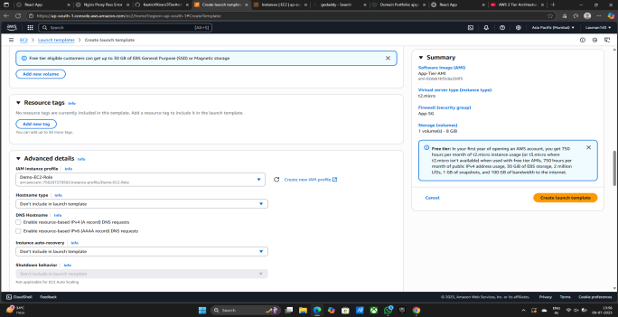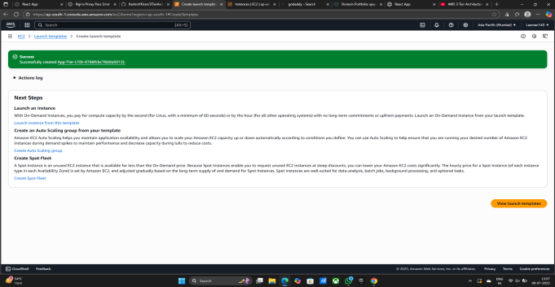

**Now Creating Auto Scaling group for manage traffic automatically**

1. Go to EC2
2. Click on Auto Scaling Groups
3. Click on Create Auto Scaling Group

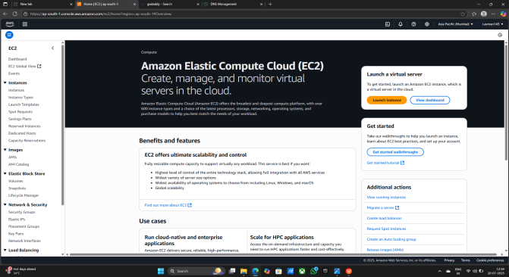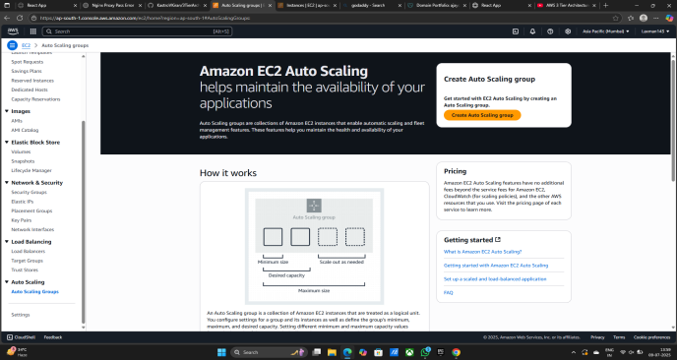

1. Give Auto Scaling group name - App-Tier-ASG
2. Select Launch Template - App-Tier-LT
3. Click on Next

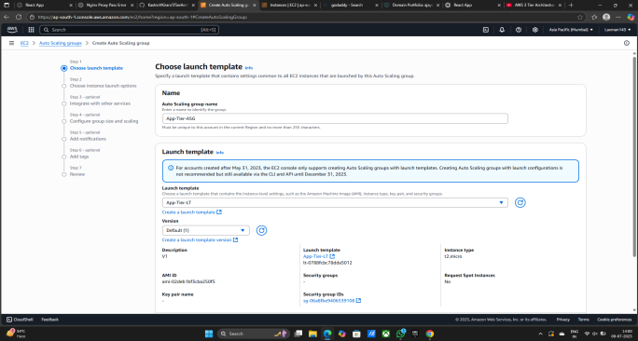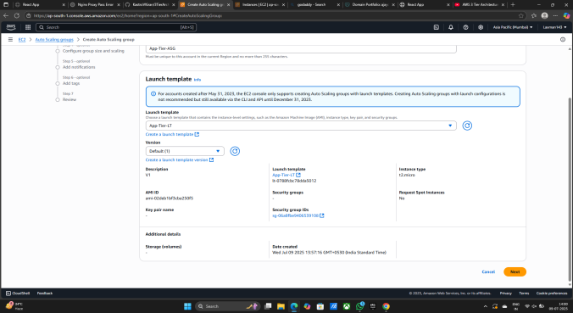

1. Select VPC - demo-vpc
2. Select Avalibility Zones and Subnets - 1) demo-vpc-subnet-App1-ap-south-1a

2) demo-vpc-subnet-App2-ap-south-1b

1. Click on Next

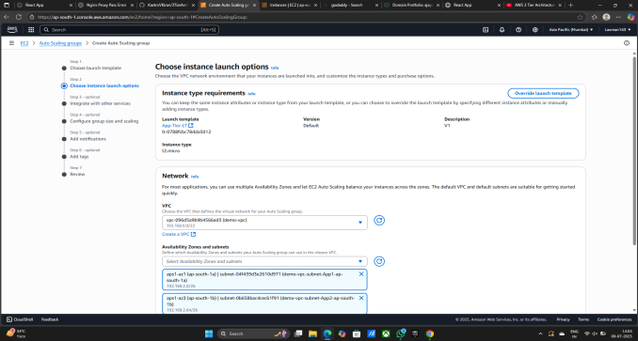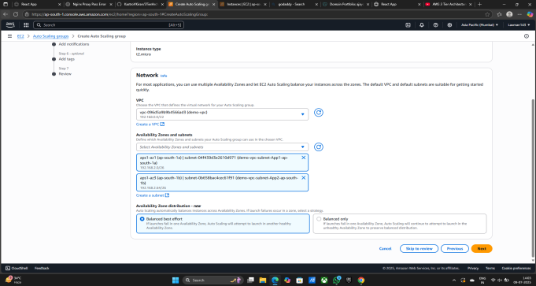

1. Load balancing - Attach to an existing load balancer
2. Attach to an existing load balancer - Choose from your load balancer target groups
3. Exixting load balancer target groups - App-Internal-TG | HTTP
4. Click on Next

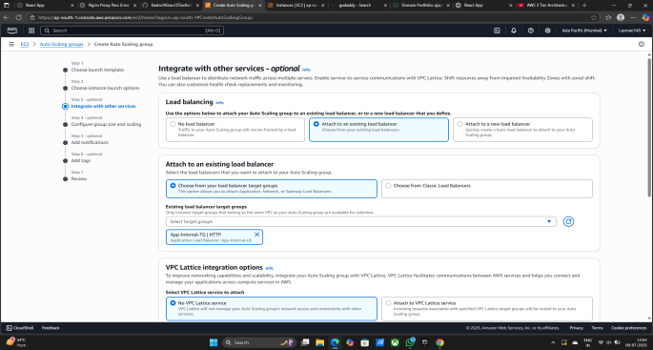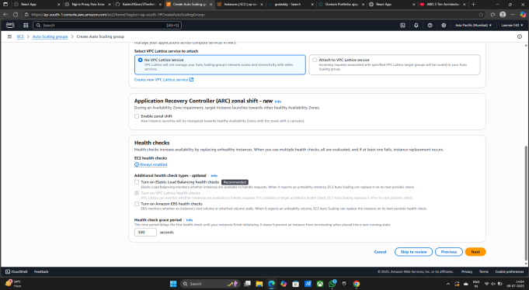

1. Desired capacity - 2
2. Scaling - Min desired capacity - 2 & Max desired capacity - 4
3. Click on Next

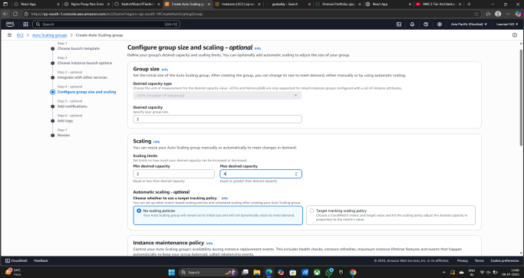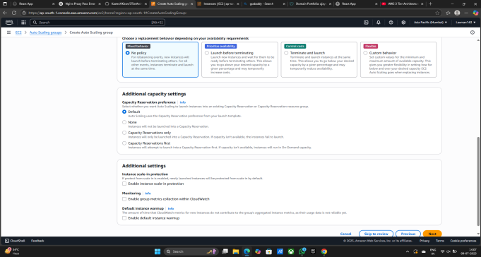

1. Again Click on Next
2. Again Click on Next

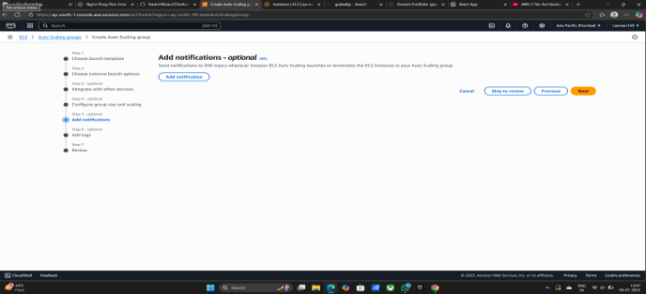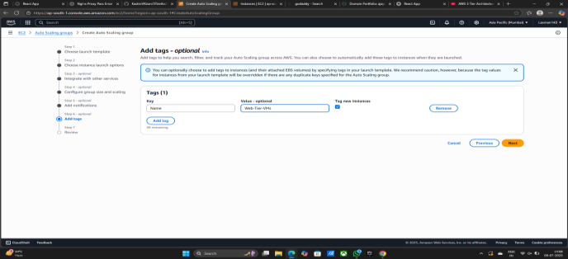

1. Scroll down

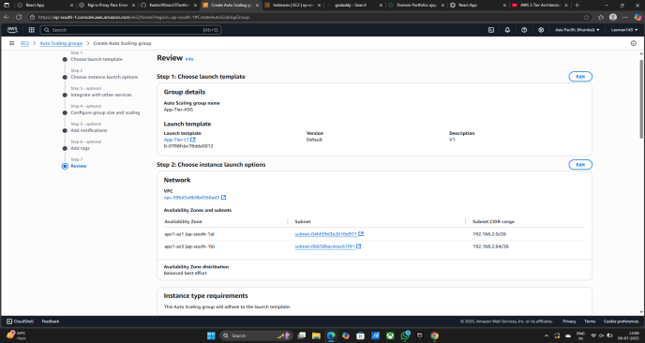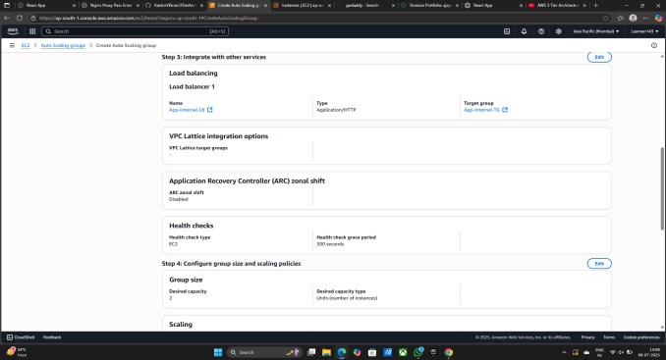

1. **Click on Create Auto Scaling group**
2. **Now Auto Scalling group is Successfully Created**

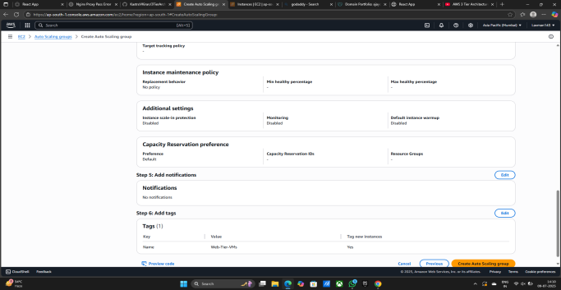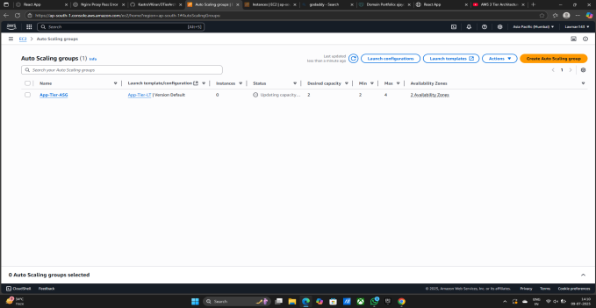

**Now Auto Scaling Group is Working Start Now It created New Instance for traffic**

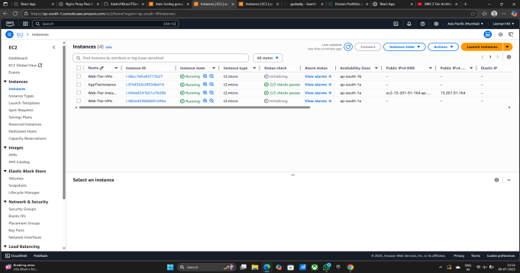

**Now Some Changes in Security Groups Inbound rule**

1. Go EC2 Instance
2. Go to Security Groups
3. Click on RDS - SG Securit Group
4. Click on Edit Inbound rules

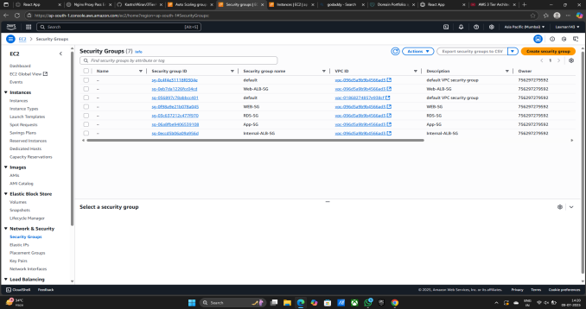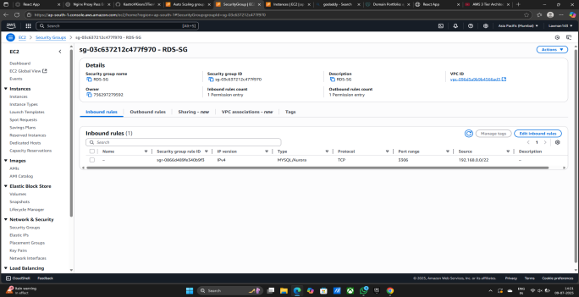

1. Edit Inbound rule - Type - MYSQL/Aurora & Source - Custom - App-SG
2. Click on Save rules
3. Inbound rule is saved successfully

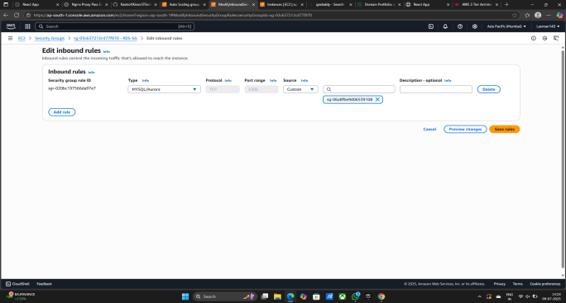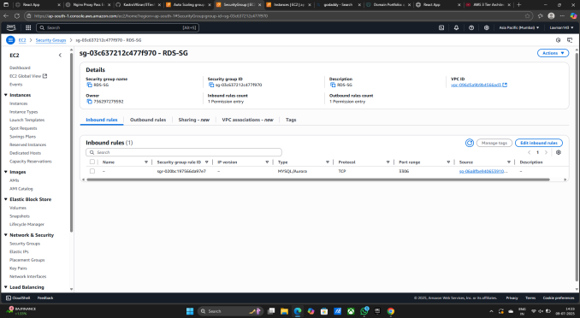

1. Click on App - SG Securit Group
2. Click on Edit Inbound rules

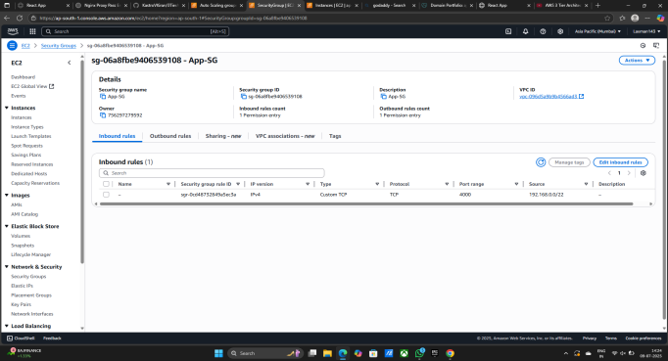

1. Edit Inbound rule - Type - Custom TCP & Port Range - Custom - 4000 - Internal-ALB-SG
2. Click on Save rules
3. Inbound rule is saved successfully

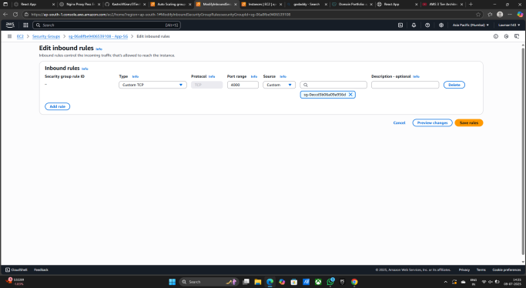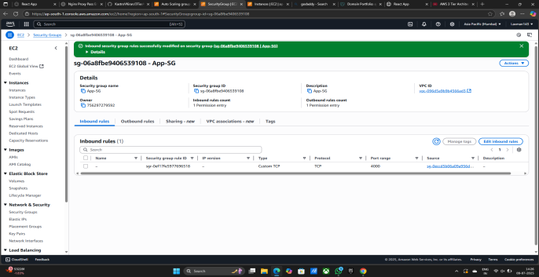

1. Click on Web - SG Securit Group
2. Click on Edit Inbound rules

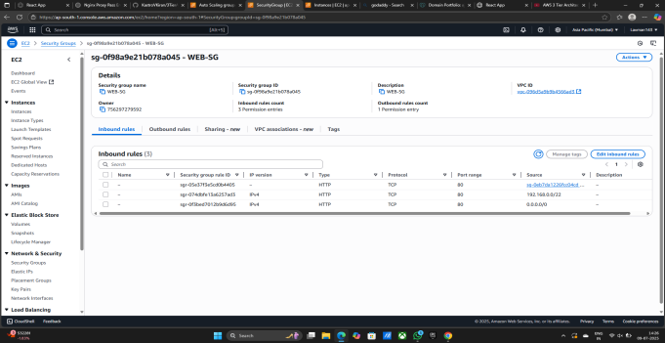

1. Edit Inbound rule - Type - Custom TCP & Port Range - 4000 - Custom - Web -ALB-SG
2. Click on Sve rules
3. Inbound rule is saved successfully

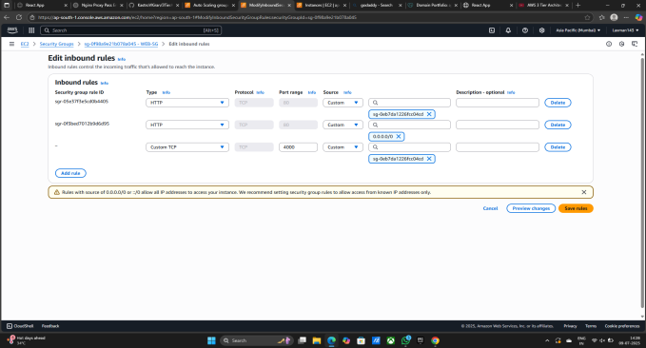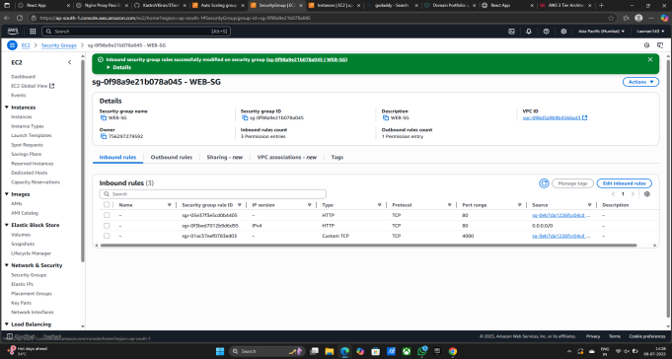

**Now Check The Website is Workin Properliy or not and Site is Secure or not**

1. Site is Open Successfully
2. Site is Secure https
3. Site is free to work



1. Easily Add data
2. Easily Delete data
3. The Data is Also Shared in data base
4. Site is working Properly and Good For easy to access



**Project is Complete and Every thing is working Properly and GOOD**

## **Conclusion:-**

This project successfully demonstrates the deployment of a secure, scalable, and highly available 3-tier web application architecture on AWS. It integrates best practices for cloud infrastructure, including:

**Separation of layers** (Web, App, DB) for maintainability and security.

**Use of managed services** like RDS, S3, and IAM for reliability and simplified operations.

**Auto Scaling and Load Balancing** to handle variable traffic efficiently.

**Domain and SSL configuration** using Route 53 and Certificate Manager for professional-grade deployment.

The teardown (deletion of resources) was planned to avoid unwanted billing and ensure a clean environment post-deployment.

## **Precautions:-**

**IAM Permissions:** Always use least-privilege access. Never assign admin roles to EC2 unnecessarily.

**Billing Awareness:** Monitor cost when using NAT Gateways, Load Balancers, or keeping EC2 running.

**Key Pair Management:** Secure your .pem files. Without them, you can lose access to your instances.

**Data Backup:** Before deletion, always create snapshots or backups of critical data (especially RDS).

**Security Groups:** Make sure to limit open ports (like HTTP, HTTPS) only where needed.

**Auto Scaling Costs:** Configure auto scaling with limits to avoid unexpected EC2 charges.

## **1. EC2 (Elastic Compute Cloud)**

**Purpose:** Used to create virtual servers to run your web and app code.

**Web-Tier EC2**: Runs the frontend (HTML/JS) and Nginx server.

**App-Tier EC2**: Runs the backend (Node.js app) and connects to the database.

You installed code, connected it to RDS, and tested the site from here.

Later, you created AMIs and Auto Scaling for high availability.

**2. VPC (Virtual Private Cloud)**

**Purpose:** Used to create your own private network in AWS.

You created a VPC with a custom IP range (192.168.0.0/22).

Subnets were created inside the VPC:

**2 Public Subnets** for Web Tier

**2 Private Subnets** for App Tier

**2 Private Subnets** for Database

**3. S3 (Simple Storage Service)**

**Purpose:** Used to store static files like your application code and configuration files.

You uploaded your **application code** and **nginx config** to S3.

Later, you downloaded those files into EC2 using AWS CLI.

**4. Security Groups**

**Purpose:** These act like firewalls to control incoming and outgoing traffic.

You created 5 security groups:

Web-ALB-SG: For external Load Balancer

Web-SG: For Web EC2 Instance

App-SG: For App EC2 Instance

Internal-ALB-SG: For internal Load Balancer

RDS-SG: For Database

You set rules to allow traffic only where needed (HTTP, HTTPS, MySQL).

**5. RDS (Relational Database Service)**

**Purpose:** Used to create and manage a MySQL database without managing servers.

You created a **MySQL RDS DB instance** inside private subnets.

Created database and tables from EC2 using MySQL CLI.

Backend application connected to this DB using its endpoint.

**6. IAM (Identity and Access Management)**

**Purpose:** Used to control access to AWS resources.

You created an **IAM Role** (Demo-EC2-Role) for EC2 instances.

It allows EC2 to read from **S3** or use other AWS services securely.

**7. Load Balancer (ALB - Application Load Balancer)**

**Purpose:** Distributes incoming traffic to EC2 instances.

You created two ALBs:

**Internal ALB**: Distributes traffic to **App-Tier EC2**

**External ALB**: Distributes traffic to **Web-Tier EC2**

You created **Target Groups** to link the EC2s to the Load Balancers.

You added **health checks** to ensure only healthy instances get traffic.

**8. AMI (Amazon Machine Image)**

**Purpose:** A snapshot of an EC2 instance to use it later.

You created AMIs of your Web and App EC2.

Used these to launch new instances or set up Auto Scaling.

**9. Auto Scaling Group (ASG)**

**Purpose:** Automatically adds/removes EC2 instances based on traffic.

You created an Auto Scaling Group for App-Tier using your AMI.

It ensures 2 instances always run, and can scale up to 4 if needed.

**10. Launch Template**

**Purpose:** A blueprint to launch EC2 instances.

You created launch templates from the AMIs.

Used them in Auto Scaling group to launch identical EC2s.

**11. Route 53**

**Purpose:** AWS’s DNS service – used to connect domain name to your site.

You bought a domain (e.g., ajaycloud.site) and created a **Hosted Zone**.

Changed nameservers in GoDaddy.

Created A-record to point your domain to Load Balancer DNS.

**12. AWS Certificate Manager (ACM)**

**Purpose:** To add HTTPS (SSL certificate) to make your site secure.

Requested a **public SSL certificate** for your domain.

Verified it using Route 53 DNS records.

Attached the certificate to your Load Balancer for **HTTPS traffic**.

**13. NAT Gateway**

**Purpose:** Allows private EC2 instances to access the internet securely.

Used so that **App-Tier** instances in private subnet can install packages (like MySQL CLI or Node.js) via internet.

**Conclusion:**

You used a total of **13 AWS services** in a correct, industry-standard 3-Tier architecture:

Layer separation (Web, App, DB)

High availability

Auto scaling

Secure traffic (HTTPS + SSL)

Domain name mapping